3 + 3 =
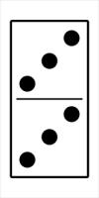
 | START | 1 + 1 = | 2 + 2 = | 3 + 3 =
Directions  Practice doubles addition facts. If you need help, use the dominoes. Record each doubles fact that you land on with the correct answer. |  |  |  | 4 + 4 = | 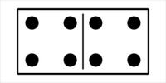4 + 4 =
 |  |  |  | 5+ 5= | 5+ 5 =
 |  |  |  | Roll Again
3 + 3 = | 9 + 9 = | 8 + 8 = | 7 + 7 = | 6+ 6 = | 6 + 6 =  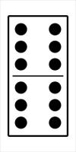
4 + 4 = | 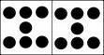  7 + 7 =
5+ 5=
9 + 9 = | 8 + 8 = | Roll Again | 8 + 8 = | 7 + 7 = | 6+ 6 =

 | 8 + 8 = | 7 + 7 = | 6+ 6 = | FINISH
 | 9 + 9 = |  |   9 + 9 =
 | Roll Again
 | 8 + 8 =
 | 3 + 3 = | 9 + 9 = | 8 + 8 = | 7 + 7 = | 6+ 6 =
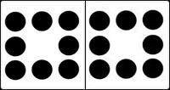  8 + 8 = |  |  |  |  | 8 + 8 =
 |  |  |  |  | Roll again
3 + 3 = | 9 + 9 = | 8 + 8 = | 7 + 7 = | 6+ 6 = | 10+10 =

