TBAT multiply 2 small numbers together (2x table)
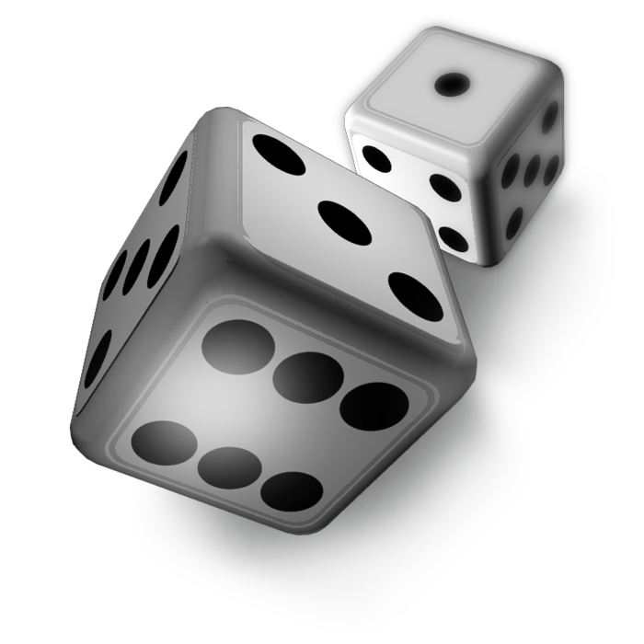

DOUBLING DICE

A game for 2 players.
You need 2 dice. Choose one colour crayon each.
Take turns to throw both the dice, find the total. Then double it, and colour in the answer on the grid.
The winner is the first person to get 3 squares coloured in, in a row.

18 | 10 | 24 | 8 | 16
14 | 12 | 6 | 14 | 20
4 | 18 | 10 | 18 | 12
20 | 8 | 14 | 6 | 16
12 | 16 | 8 | 14 | 4
10 | 18 | 12 | 16 | 24
4 | 22 | 10 | 14 | 6

