Equivalent Fractions to ½

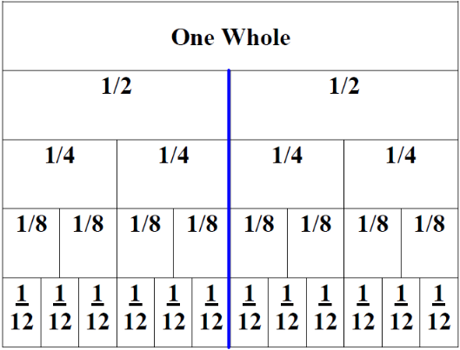

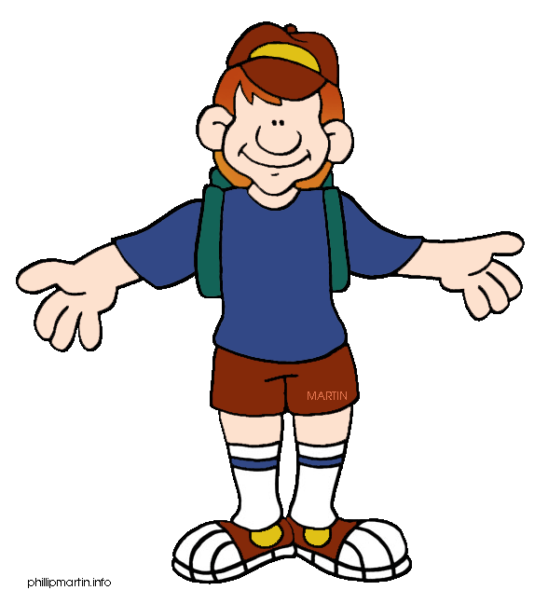
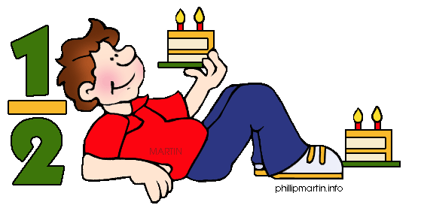

Task 1)
Use the fraction wall, colour a half and complete these equivalent fractions.

- $12$ = $4$ b) $12$ = $8$ c) $12$ = $\text{12}$

Task 2)
Shade in half of each shape and write the fraction you’ve drawn.
a) b) c)

Task 3)
Shade in quarter of each shape and write the fraction you’ve drawn.

