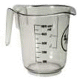
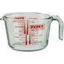
Measuring Capacity

Draw and label the container | What capacity do you think it holds? (ml) | What is the real capacity? (ml)
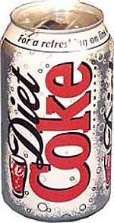  E.g. | 200 ml | 330ml

Measuring Capacity
Draw and label the container | What capacity do you think it holds? (ml) | What is the real capacity? (ml)
E.g. | 200 ml | 330ml

Which container has the least capacity?____________________________________________________

Which container has the most capacity?____________________________________________________
Measuring Capacity

Draw and label the container | What capacity do you think it holds? (ml) | What is the real capacity? (ml) | What is the difference between your estimate and the real capacity? | Convert the real amount into ml or l.  (1l = 1000ml)
E.g. | 200 ml | 330ml | 1 130ml | 0.130l

Which container has the least capacity?____________________________________________________

Which container has the most capacity?____________________________________________________

