I have 97  2² + 6 |  | I have 10  3² X 4
I have 36  2³ + 17 |  | I have 25  4² + 12
I have 28  10³ -40 |  | I have 960  5³ + 19
I have 144  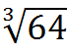 + 4³ |  | I have 68  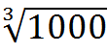 + 19
I have 29  10² + 3 - 6 |  | I have 97  13 + 5²
I have 38  60 + 3³ |  | I have 87  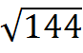 X 6

I have 72  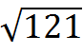 X 4 |  | I have 44  2² + 2² + 2²
I have 12  100 – 5² |  | I have 75  50% of 8²
I have 32  110 – 9² |  | I have 29  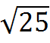 + 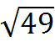
I have 12  90 – 7² |  | I have 41  2³ X 5
I have 40  6² + 2³ |  | I have 44  1³ X 0 + 3
I have 3  47 - 4² |  | I have 31  9² more than 16

