 |  | 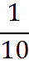 | 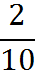 | 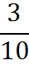 | 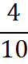
0.1 | 0.5 | 0.2 | 50% | 0.6 | 0.7

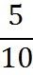 | 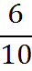 | 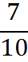 | 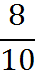 | 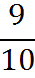 | 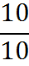
30% | 0.25 | 50% | 20% | 0.3 | 60%

 | 25% | 40% | 10% | 0.8 | 90%
0.5 | 70% | 80% | 0.4 | 0.9

1

75% | 100% | 33.3% | 0.75 |  | 0.33...

