Finding 10 more

Learning objective: To be able to work out 10 more than any given number.

Work out what 10 more of these numbers are:

10 more than 20 = _______ 10 more than 30 = _______

10 more than 60 = _______ 10 more than 70 = _______

10 more than 10 = _______ 10 more than 90 = _______

10 more than 40 = _______ 10 more than 80 = _______

Using your number squares, work out what 10 more than these numbers are:

10 more than 7 = _______ 10 more than 3 = _______

10 more than 9 = _______ 10 more than 10 = _______

10 more than 15 = _______ 10 more than 25 = _______

10 more than 37 = _______ 10 more than 59 = _______

Finding 10 more

Learning objective: To be able to work out 10 more than any given number.

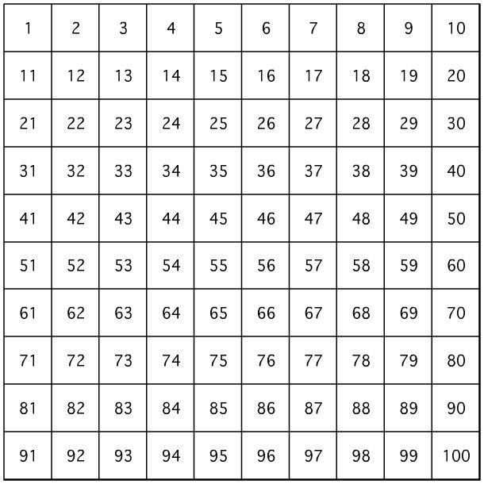

Using the number square, work out 10 more of these numbers:

10 more than 20 = _______ 10 more than 30 = _______

10 more than 60 = _______ 10 more than 70 = _______

10 more than 10 = _______ 10 more than 90 = _______

10 more than 15 = _______ 10 more than 35 = _______

10 more than 48 = _______ 10 more than 67 = _______
Learning objective: To be able to work out 10 more than a number.

Number rolled: | 10 more?
10 | 20

Draw lines to match these numbers to the number that is 10 more:

10 70 25 84 46

35 20 56 80 94

