Finding Fractions of Numbers and Shapes.
L.o. To use division to find fractions of numbers and shapes
To find a fraction of a number you divide by the bottom number and multiply by the top number. This is because the denominator tells us how much to break the whole into and the numerator tells us how much of the whole we are talking about.
To find ¾ of 12:
12 ÷ 4 = 3
(Divide the whole by the denominator)
3 x 3 = 9
(Multiply the answer by the numerator)
So ¾ of 12 = 9
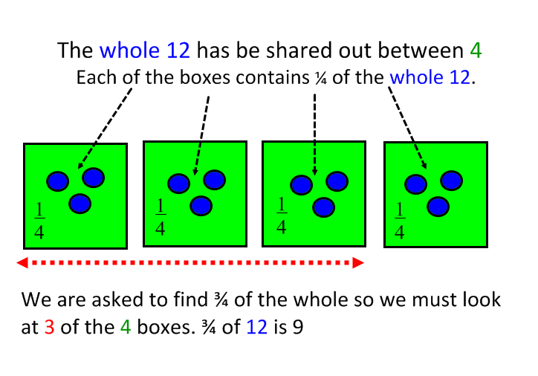

Use this method to help you answer these questions.

- ⅕ of 20 = ___
- ⅛ of 16 = ___
- ⅙ of 18 = ___
- ⅓ of 30 = ___
- ¼ of 32 = ___
- ⅓ of 27 = ___
- ⅕ of 25 = ___
- ⅛ of 24 = ___
- ½ of 36 = ___
- ¼ of 36 = ___

Now shade the correct amount of these shapes.
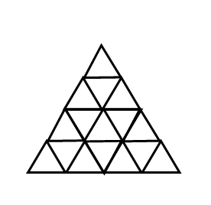  ⅛ | 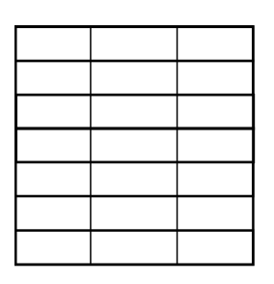  ⅓ | 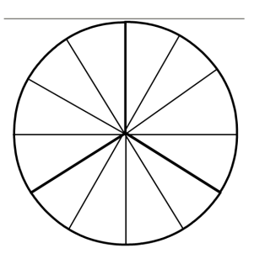  ⅙ | 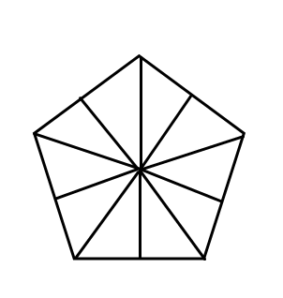  ⅕
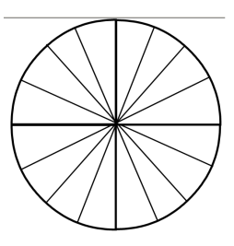  1/10 | ½ | 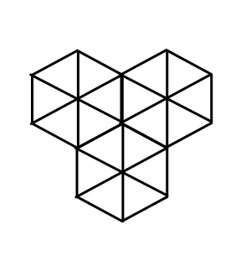  1/9 | 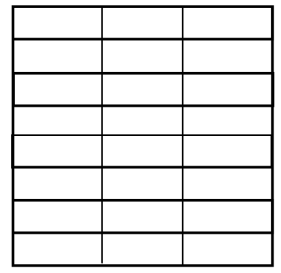  ⅙

Finding Fractions of Numbers and Shapes.
L.o. To use division to find fractions of numbers and shapes
To find a fraction of a number you divide by the bottom number and multiply by the top number. This is because the denominator tells us how much to break the whole into and the numerator tells us how much of the whole we are talking about.
To find ¾ of 12:
12 ÷ 4 = 3
(Divide the whole by the denominator)
3 x 3 = 9
(Multiply the answer by the numerator)
So ¾ of 12 = 9

Use this method to help you answer these questions.

- ⅕ of 30 = ___
- ⅛ of 16 = ___
- ⅙ of 18 = ___
- ⅓ of 30 = ___
- ¼ of 32 = ___
- ⅔ of 27 = ___
- ⅖ of 25 = ___
- ⅜ of 40 = ___
- ¾ of 36 = ___
- ⅚ of 36 = ___
- ⅞ of 32 = ___
- ⅔ of 36 = ___
- ¾ of 48 = ___
- ⅘ of 45 = ___
- ⅜ of 48 = ___

Now shade the correct amount of these shapes.
⅛ | ⅓ | ⅙ | ⅕
¾ | 8/10 | 2/9 | ⅚

Finding Fractions of Numbers and Shapes.
L.o. To use division to find fractions of numbers and shapes
To find a fraction of a number you divide by the bottom number and multiply by the top number. This is because the denominator tells us how much to break the whole into and the numerator tells us how much of the whole we are talking about.
To find ¾ of 12:
12 ÷ 4 = 3
(Divide the whole by the denominator)
3 x 3 = 9
(Multiply the answer by the numerator)
So ¾ of 12 = 9

Use this method to help you answer these questions.

- ⅕ of 30 = ___
- ⅛ of 16 = ___
- ⅚ of 18 = ___
- ⅘ of 30 = ___
- ⅞ of 32 = ___
- ⅔ of 27 = ___
- ⅖ of 25 = ___
- ⅜ of 40 = ___
- ¾ of 36 = ___
- ⅚ of 36 = ___
- ⅞ of 48 = ___
- ⅔ of 36 = ___
- ¾ of 48 = ___
- ⅘ of 45 = ___
- ⅜ of 72 = ___

Now shade the correct amount of these shapes.
⅜ | 3/7 | ⅚ | ⅘
¾ | 8/10 | 2/9 | 5/12

