Name ________________________________________________________________________________________________________________________ Date ___________________________________________________________
LO: to solve combination problems
- Using the colours blue, green and yellow only. How many different colour combinations of stripes can you put on these flags? You can use each colour only once in each flag.
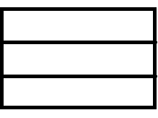
- Using the colours blue, green, yellow and pink only, how many different colour combinations of stripes can you put on these flags. You can use each colour only once in each flag.
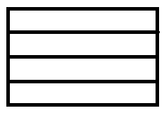
Are there any more? Draw them here? >

- Using these shapes – 1 circle, 1 square and 1 triangle, in how many different orders can you put them (you can use each shape only once and they must be side by side!) Draw them on this line.
Here is an example. What order would you put them in next?

___________________________________________________________________________________________________________________________________________________________________________________________

- Make a similar puzzle of your own. Work out the answers here and then test it on a friend.

