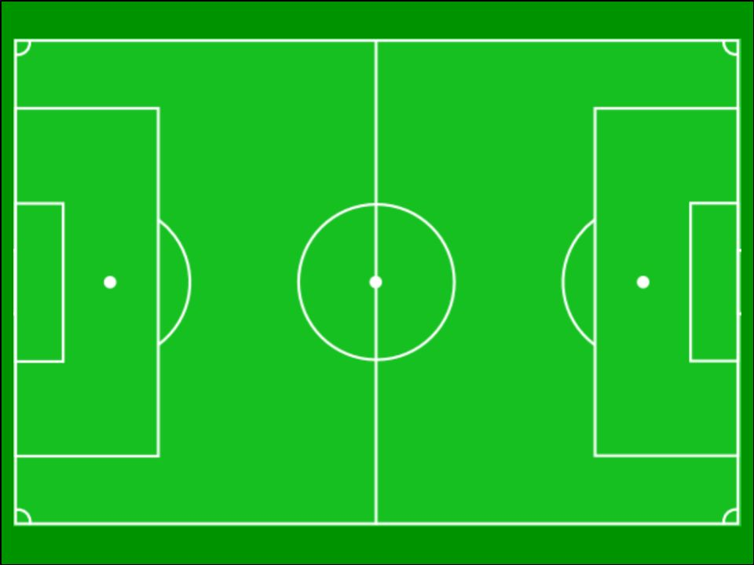
1
0
2
3
4
5
6
7
0
1
2
3
4
5
6
7
8
9
10
11
Football Coordinates
A first-quadrant coordinates grid, overlaid onto a football pitch image.

I normally enlarge this to A3. Suitable for any coordinates activity in the first quadrant. I like to combine it with images of football players, so children can place players and organise a team on the pitch. Children could draw their own players.



