Problem Solving using Calculators and Fractions

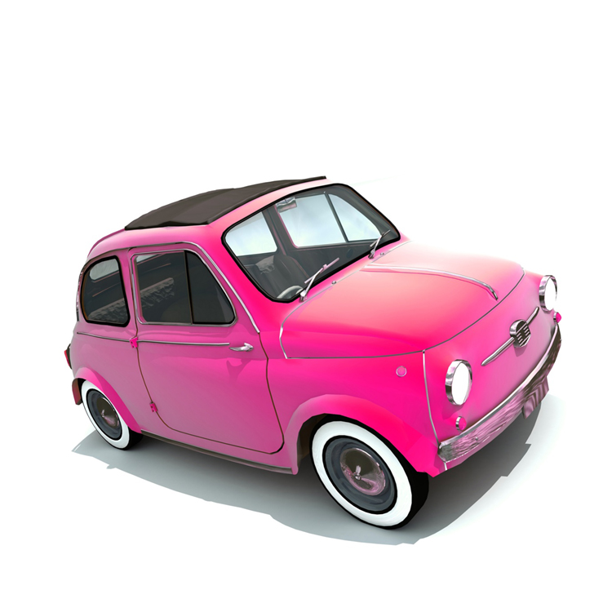
- My car holds 38 litres of petrol in its tank when it is full. I used ¼ of the petrol to go to my sister’s house.

  - How much did I use?
  - How much petrol was left in my car?

Estimate; calculate; check! Show all workings.

- I walked ²/₃ of the way to school when I discovered that I had forgotten my Learning Log. I turned round and went back to get it. It is 654m to school.

  - How far had I walked before I turned round to go and get my homework?
Estimate; calculate; check! Show all workings.

- For my birthday I was given a lot of money. I put £55 in my savings account – this was half of what I was given. I spent ¹/₅ of what I was given on a game and I used ¼ to buy a hamster and a cage.
  - How much was I given altogether?
  - How much did I spend on the game?

  - How much did I spend on the hamster and cage?
  - How much did I have left?

Estimate; calculate; check!
Show all workings.

CHALLENGE QUESTIONS!

- For a competition prize £122 is shared out.

Jade gets ¹/₄; Tan gets ²/₅ and Sadie gets ³/₁₀.

Matt gets the rest.

How much does he get?
Estimate; calculate; check!
Show all workings.

- I noticed that the new bottle of squash I bought was different. It said that it was more concentrated and that I only needed to use half of what I usually used.
  - I usually use 250ml of squash in my jug and then add water. How much should I now use?
  - My jug holds 1.250litres. How much water should I add to the squash to make it up to 1.250 litres?

- A man shares out most of his valuable horses to his children. He gives ¼ to Sam. This is 9 horses. He gives ¹/₃ to Andy and ²/₉ to Fiona.
  - How many do Andy and Fiona get?
  - He keeps the rest as they are old. How many does he keep?

Estimate; calculate; check! Show all workings.

