LO: To find fractions of numbers and quantities and record using notation

Fractions 9/01/14 Name: _________________

 Remember ½ means you share into 2 equal groups
Remember ¼ means you share into 4 equal groups

Use 6 cubes
- ½ of 6 =

Use 8 cubes
- ½ of 8 =
- ¼ of 8 =

Use 10 cubes
- ½ 0f 10 =
- ¼ 0f 10 =

Challenge!

Can you share larger numbers of cubes into halves and quarters?
Record your number sentences in your maths book

LO: To find fractions of numbers and quantities and record using notation

Fractions 9/01/14 Name: _________________

Remember ½ means you share into 2 equal groups
Remember ¼ means you share into 4 equal groups

Use 10 cubes
- ½ of 10 =

Use 12 cubes
- ½ of 12 =
- ¼ of 12 =

Use 16 cubes
- ½ 0f 16 =
- ¼ 0f 16 =

Challenge!

Can you share larger numbers of cubes into halves and quarters?
Record your number sentences in your maths book

LO: To find fractions of numbers and quantities and record using notation

Fractions 9/01/14 Name: _________________

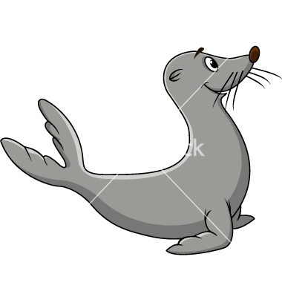Remember ½ means you share into 2 equal groups
Remember ¼ means you share into 4 equal groups

Use 12 cubes
- ½ of 12 =

Use 16 cubes
- ½ of 16 =
- ¼ of 16 =

Use 20 cubes
- ½ 0f 20 =
- ¼ 0f 20 =

Challenge!

Can you share larger numbers of cubes into halves and quarters?
Record your number sentences in your maths book

Do you notice anything interesting about finding fractions of numbers?
________________________________________________________________________________________

