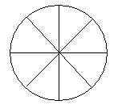
- Shade one half of these shapes:

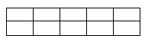
- Shade one quarter of these shapes:
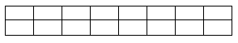

3. What fraction of the sweets are in the box? What fraction are outside the box?

a) b)

in out in out

- ½ of 12 = _____
- ½ of 20 = _____
- ½ of 24 = _____

- ¼ of 12 = _____
- ¼ of 4 = _____
- ¼ of 40 = _____

- ¹/₃ of 9 = _____
- ¹/₃ of 12 = _____
- ¹/₃ of 30 = _____

- ¹/₁₀ of 10 = _____
- ¹/₁₀ of 20 = _____
- ¹/₁₀ of 50 =_____

- Draw a circle around the following fractions of these amounts:

a) ½ b) ¼ c) ¹/₃

