Geometry – Level 3
Name: ______________________________________ Room: ___________________________ Year: 5 6

Knowledge and Skills to be explored with Students.

□make 2-dimensional shapes  A1: Make shapes using compasses and protractors
□make models of a sphere, cuboid and pyramid  A2: Make/study models of pyramid, cuboids, spheres
□talk about the special features of 2 & 3- dimensional shapes e.g. square , circle ,triangle and ellipse  A3: Study features of plane shapes
□pull everyday packages apart to identify the type of net used, reassemble a range of packages  A4: Pull apart models of packages, study nets, reassemble.
□draw patterns that have rotational symmetry  A5: Complete rotational symmetry patterns
□talk about what happened when an object is turned  A6: Turn objects to new directions
□explore a variety of ways of covering surfaces.  A7: Tesselations
□use appropriate geometric language to describe shapes and objects  A8: Describe plane and solid shapes
□describe their shape as a result of cutting a cross section at various points on the object  A11: Describe cross sections
□enlarge shapes using grid paper  A12: Enlarge a shape using a grid
□investigate tessellating shapes  A13: Tesselation
□rotate, reflect and translate shapes to design patterns  A14 Rotate, Reflect and translate shapes to make a pattern:
□use mirrors to explore reflection  A15: Use mirror, check reflection
□design patterns that involve transposing a pattern through a reconfiguration : to the right or A16: Make a pattern using one shape rotated and tessellated.
left, clockwise or anti clockwise, a mirror image.

□ Make 2-dimensional shapes
In the spaces below, draw the following Shapes to the instructions given.

Rectangle: 6cm by 3.5cm
Square: 5cm by 5cm
Triangle: Base 6cm side 1 5cm side 2 4cm
Circle: Radius 3cm

Rhombus: Sides 4cm
Trapezuim: Top 4cm bottom 6cm
Kite: Sides 5cm and 3cm
Hexagon: Radius 3cm

□ make models of a prism, cube and pyramid

Use the squares to design how to make nets for a triangular prism, a cube and a pyramid.

○ A3: Study features of plane shapes

Trapezium Oblong Kite Quadrilateral

Square Parallelogram Rhombus
This is a It hasHow many sidesHow many anglesHow many pairs ofParallel sidesHow many sides the same lengthHow many same sized angles
This is a It hasHow many sidesHow many anglesHow many pairs ofParallel sidesHow many sides the same lengthHow many same sized angles
This is a It hasHow many sidesHow many anglesHow many pairs ofParallel sidesHow many sides the same lengthHow many same sized angles
This is a It hasHow many sidesHow many anglesHow many pairs ofParallel sidesHow many sides the same lengthHow many same sized angles
This is a It hasHow many sidesHow many anglesHow many pairs ofParallel sidesHow many sides the same lengthHow many same sized angles
This is a It hasHow many sidesHow many anglesHow many pairs ofParallel sidesHow many sides the same lengthHow many same sized angles
This is a It hasHow many sidesHow many anglesHow many pairs ofParallel sidesHow many sides the same lengthHow many same sized angles

Triangles: There are seven kinds of triangles. Look at each of the descriptions below.

Equilateral Triangle  (All sides the same length.) | An equilateral triangle has three sides, and three internal angles. All sides are the same length, and all angles equal 60⁰.
Isosceles Triangles  (Two sides the same length.) | The three kinds of isosceles triangles have two sides the same length, and two angles the same measurement.
Scalene Triangles  (All sides a different length.) | The three kinds of scalene triangles have no sides the same length, and no angles the same measurement.

Which is each kind of triangle? Write the name of the triangle inside each.

 | Triangle Name | Tell about the sides | Tell about the angles
1 | Equilateral Triangle
2 | Right Isosceles
3 | Acute Isosceles
4 | Obtuse Isosceles
5 | Right Scalene
6 | Acute Scalene
7 | Obtuse Scalene

Show using torn paper
that the three angles of a triangle add up to 180^{0.}
( A straight angle.)

□draw patterns that have rotational symmetry

talk about what happened when an object is turned

A Congurent and Similar Shapes.

Congruent means the same shape and size as. Similar means same shape but different size. To apply this in geometry, shapes are compared. If the shape is identical in every way (length of sides, shape, angles) then the shapes are congruent. If the shapes have the same shape and angle, but the sides are a different length, then they are similar.

Compare the shapes below for congruency, or similarity.

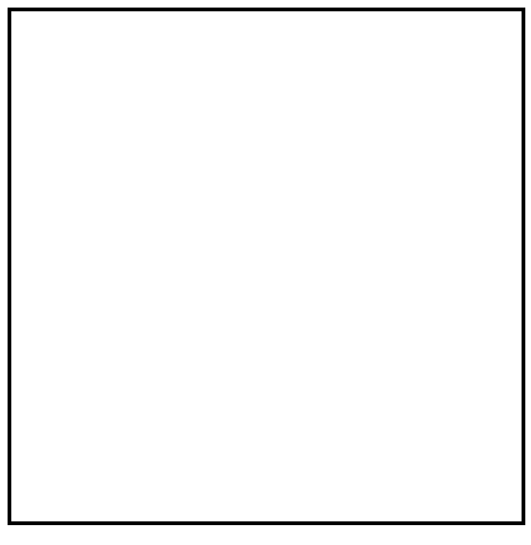 | 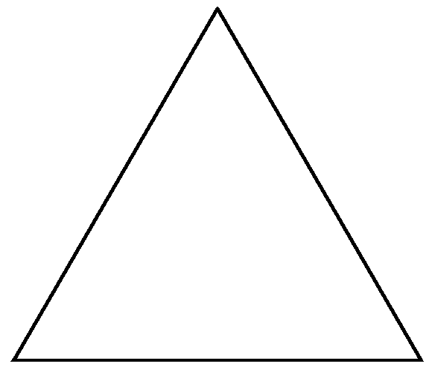 | 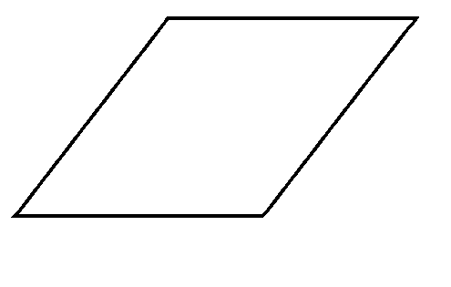 | 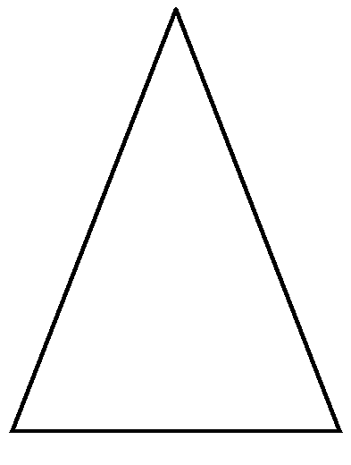
A is similar to | B is similar to | C is congruent to | D is congruent to | E is similar to
 |  |  | 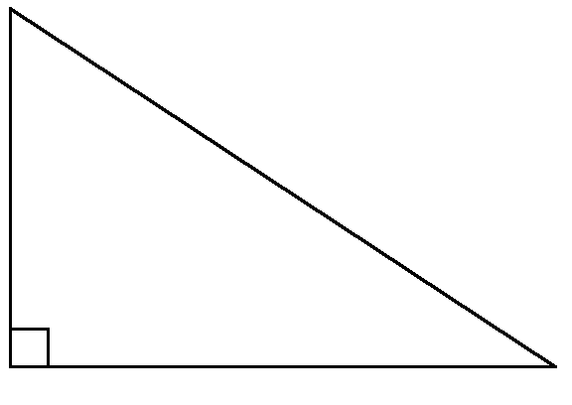
F is similar to | G is congruent to | H is congruent to | I is congruent to | J is congruent to
K is similar to | L is similar to | M is similar to | N is congruent to | O is similar to

The Circle

Segment  Chord  Circumference Diameter  Centre  Sector  Radius  Arc  Tangent | Describe each part of the circle.  Circumference  Segment  Tangent  Chord  Centre  Diameter  Sector  Radius  Arc
Diameter = 18cm  45⁰  Circumference = d x ∏ ( ∏ = 3.14 )  Area = ∏ X r² | Solve these circle problems.  - A Chord cuts a circle into two _____________  - A diameter cuts a circle into two ______________  - When a diameter meets a tangent, it makes a _____⁰ angle.  - Two radii and an arc border a ________________  - A chord and an arc border a ________________  - The diameter measures __________ cm  - The radius measures _________ cm  - The circumference of the circle measures ________ cm  9. The area of the circle measures _________ cm²

Diagonals

 | 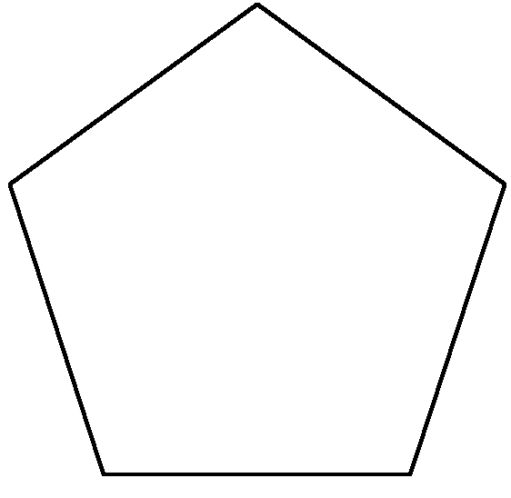 | 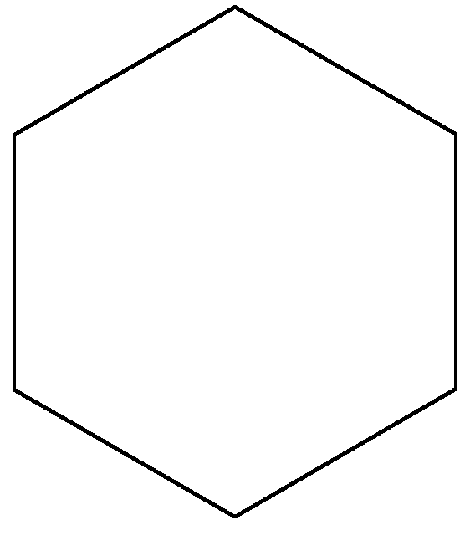
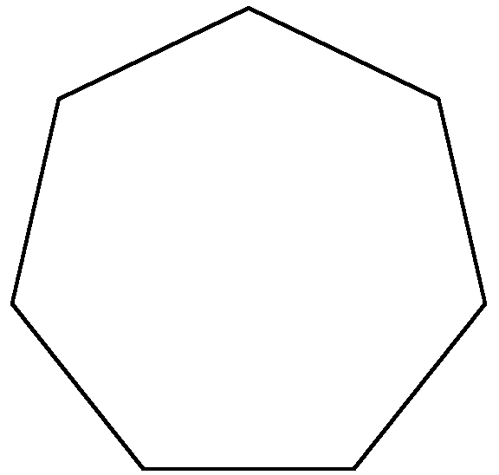 | 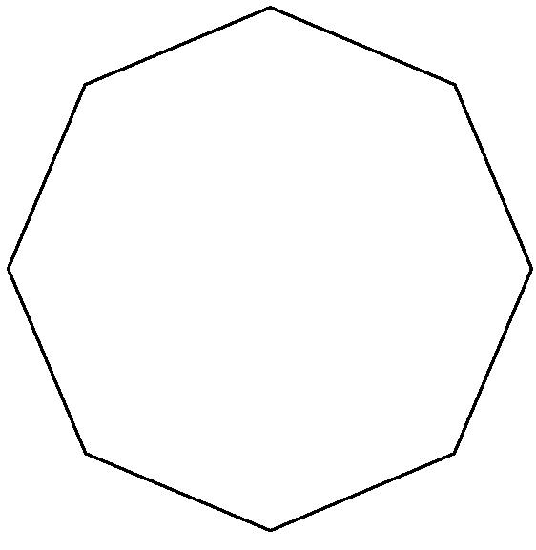 | 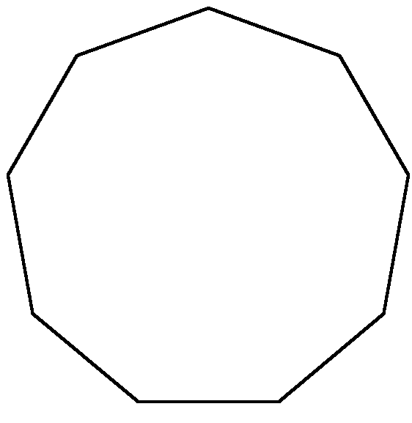
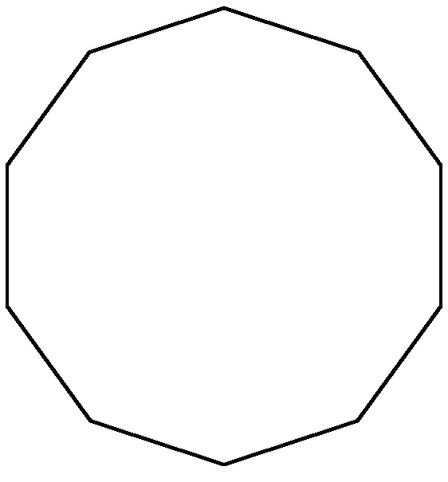 | 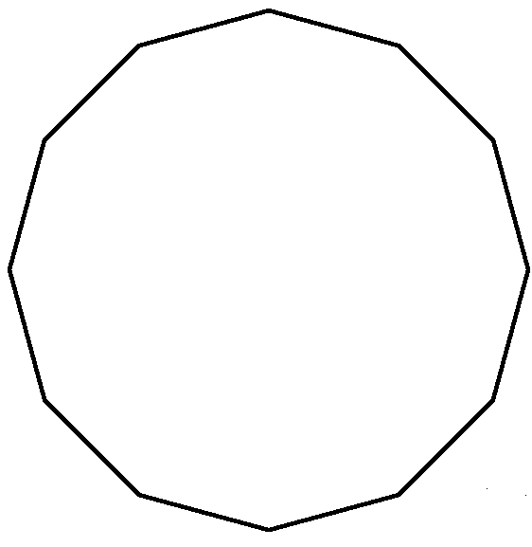 | Complete the following table  Edges Ver Diags  Square  Pentagon  Hexagon  Heptagon  Octagon  Nonagon  Decagon  Duodecagon

Describe the | Edges
Pattern for Edges, | Vertices
Vertices and Diag. | Diagonals

Transformation Geometry

A transformation is a change of: fitting together without gaps (TESSELLATION)
viewpoint (ROTATION), location (TRANSLATION), reversal of shape (REFLECTION), size ( DILATION).

Tessellation Which of the following are tessellations?

Show in each space below that the following shapes tessellate. Colour in two colour pattern.

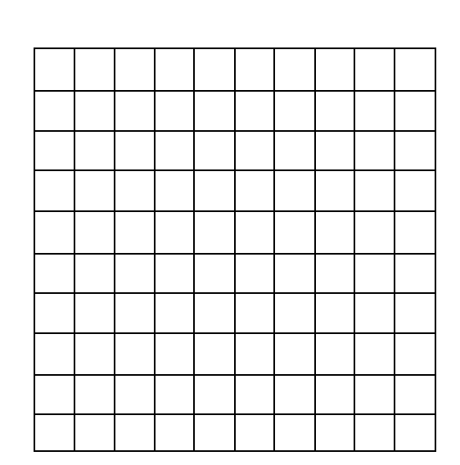
Isosceles Triangle | Square | Rhombus | Oblong | Hexagon
Kite | Parallelogram | Trapezium | Right Triangle | Arrowhead

Rotation Objects can be rotated through 360⁰. Each object has a point of rotation and an
order of rotation ( the number of stops the object has to complete one turn.)
For each of the following, show the point of rotation and the order of rotation.

PR | PR | PR | PR | PR
OR | OR | OR | OR | OR
PR | PR | PR | PR | PR
OR | OR | OR | OR | OR

Translation Translation is the action of sliding a shape to a new position.
Instructions for the move are given:⁺3/⁻2(Means 3 spaces to right, two down)
Explain what these translation directions say
⁺2 / ⁻4 |  | ⁺4 / ⁻3
⁻ 3 / ⁻ 2 |  | ⁻ 2 / ⁻ 3
⁺4 / ⁺ 1 |  | ⁺5 / ⁺ 2
⁻ 5 / ⁺ 3 |  | ⁻ 3 / ⁺ 4

Translate the following shapes, then draw them in their new location.

+ 8 / -3

+7 / -1
- 3 / 0
0 / -3
-6/+2

-6/ -2

enlarge shapes using grid paper
Enlarging makes bigger.
Reducing makes smaller.

1. Enlargement by Lines
and V. point.

Enlarging and reducing can also be carried out using a grid method. Try this by copying from square to square.

- Enlargement and reduction can be carried out by use of grids.

Cut into quarters, then sixteenths, and transfer from one grid to the other.

3. Distort this picture using the grid method.

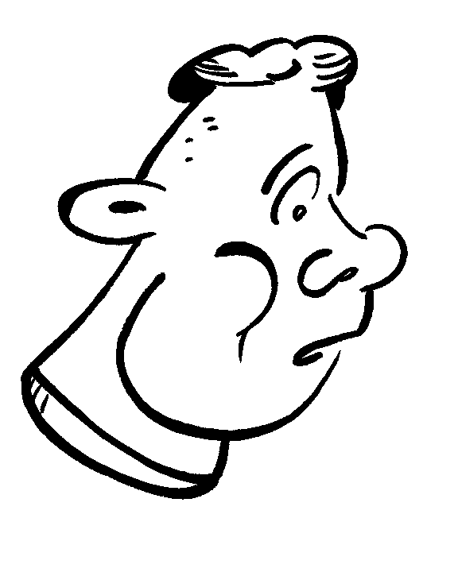

Solve these Linear Geometry Problems.

 | Problem |  | Your Answer
1 | How many lines segments can be rules through a point? Try it, then give your answer.  
2 | How many line segments can be ruled through two points?   
3 | How many line segments can be ruled through any two points below?  -   -    
4 | How many rays can begin from this point?  
5 | How many pairs of parallel lines can you name?  A B C D E F G H I J K L M  N O P Q R S T U V W X Y Z |  | AN \\ to BO , AN \\ to CP,
6 | Show where these pairs of skew lines will cross.
7 | How long is a line?
8 | How long is a ray?
9 | F   K  R  I  G   B |  | How many curves can you name?
3G4 |  | Examine and describe geometric shapes, using the language of geometry.

Plane Geometry Elements, their Features and their Relationships. Name each of the following plane shapes, then record some of their features on the chart below.
1 | 2 | 3 | 4 | 5
6 | 7 | 8 | 9 | 10
11 | 12 | 13 | 14 | 15
16 | 17 | 18 | 19 | 20

Shape | Num | Fold Lines | Straight Sides | Equal length sides | Parallel Sides | Corners | Diagonals
semi - circle
arrowhead
heptagon
duodecagon
kite
nonagon
oblong
square
parallelogram
trapezium
rhombus
decagon
right triangle
octagon
circle
isos triangle
hexagon
pentagon
equil triangle
Ellipse

