
Price List

Loaf of Bread 20p

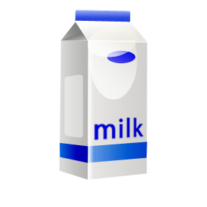
Milk 10p

Bar of chocolate 30p

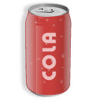
6 cans of Coke 40p

Bag of potatoes 20p

Price List

Loaf of Bread 35p

Milk 15p

Bar of chocolate 10p

6 cans of Coke 85p

Bag of potatoes 25p

4 apples 35p

Newspaper 5p

Comic 95p

Price List

Loaf of Bread 50p

Milk 10p

Bar of chocolate 45p

6 cans of Coke £1.50

Bag of potatoes £1.00

4 apples 95p

Newspaper £1.75

Comic £2.25
Going Shopping

With a partner work out the answers to the following problems using your price list.

Sam spends £4.00. Which 2 items could he have bought?

Could Sam have bought 3 items with £4.00? Which ones?

(clue ~ he may have some money left over)

John spends £1.40 in the shop. What did he buy?

If Jane gave the shopkeeper £5 and received £3.25 change, what did she buy?

Show three ways to spend £1.50 in the shop.

Going Shopping

With a partner work out the answers to the following problems using your price list.

Sam spends 70p. Which 2 items could he have bought?

Hamish spends £1.15. Which 3 items could he have bought?

John spends 40p in the shop. What did he buy?

If Jane gave the shopkeeper £1 and received 15p change, what did she buy?

If you had £1 what would you buy in the shop?
How much change would you get?

Going Shopping

Work out the answers to the following problems using your price list.

