Imperial Units
OLI:____________________________
________________________________
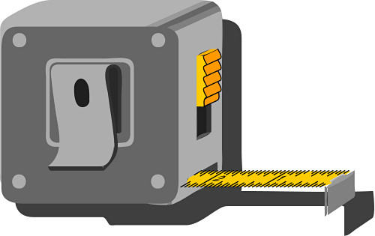
Use one of these three sentences beside each unit of measurement to explain what it is used for.

- Used to measure volume
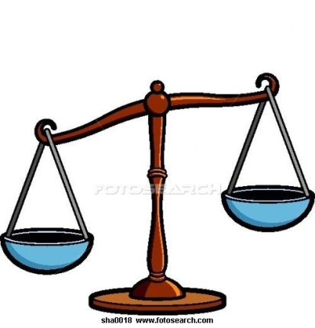
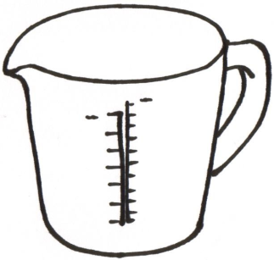
- Used to measure distance

- Used to measure weight

- Fluid ounces are__________________________________________
- Pounds are______________________________________________
- Miles are_______________________________________________
- Pints are_______________________________________________
- Inches are______________________________________________
- Stones are______________________________________________
- Gallons are______________________________________________
- Feet are________________________________________________
- Ounces are______________________________________________

