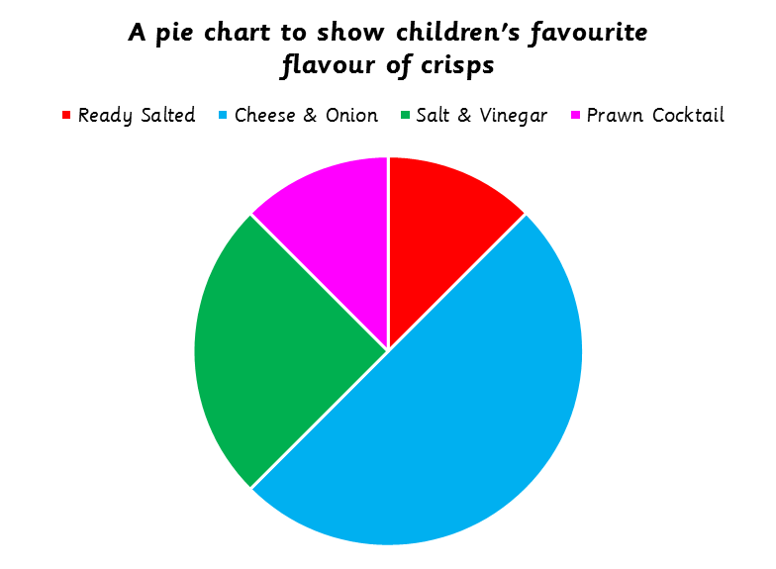 | This pie chart represents 40 children
 | 1. How many children chose Cheese & Onion as their favourite flavour?
 | 2. How many children chose Salt & Vinegar as their favourite flavour?
 | 3. How many children chose Ready Salted as their favourite flavour?
 | 4. How many children chose Prawn Cocktail as their favourite flavour?
 | 5. Which flavour was the most popular?
 | 6. Which flavour was the least popular?

This pie chart represents 40 children
1. How many children chose Cheese & Onion as their favourite flavour?
2. How many children chose Salt & Vinegar as their favourite flavour?
3. How many children chose Ready Salted as their favourite flavour?
4. How many children chose Prawn Cocktail as their favourite flavour?
5. Which flavour was the most popular?
6. Which flavours were the least popular?

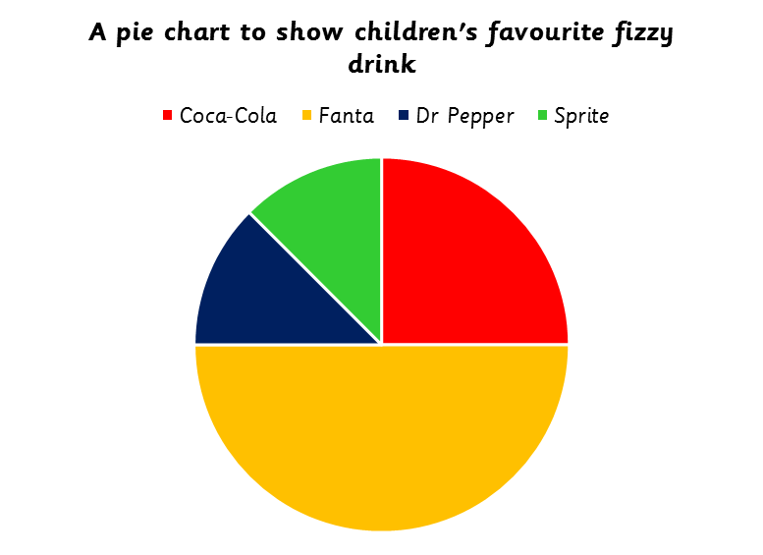 | This pie chart represents 40 children
 | 1. How many children chose Coca-Cola as their favourite fizzy drink?
 | 2. How many children chose Dr Pepper as their favourite fizzy drink?
 | 3. How many more children chose Fanta than those that chose Sprite?
 | 4. Using the information in the pie chart, if you had to buy some fizzy drinks for a party, and could only buy 8 bottles, how many of each would you buy?
 | Bottles of Fanta |  | Bottles of Sprite
 | Bottles of Coca Cola |  | Bottles of Dr Pepper

 | This pie chart represents 40 children
 | 1. How many children chose Coca-Cola as their favourite fizzy drink?
 | 2. How many children chose Dr Pepper as their favourite fizzy drink?
 | 3. How many more children chose Fanta than those who chose Sprite?
 | 4. Using the information in the pie chart, if you had to buy some fizzy drinks for a party, and could only buy 8 bottles, how many of each would you buy?
 | Bottles of Fanta |  | Bottles of Sprite
 | Bottles of Coca Cola |  | Bottles of Dr Pepper

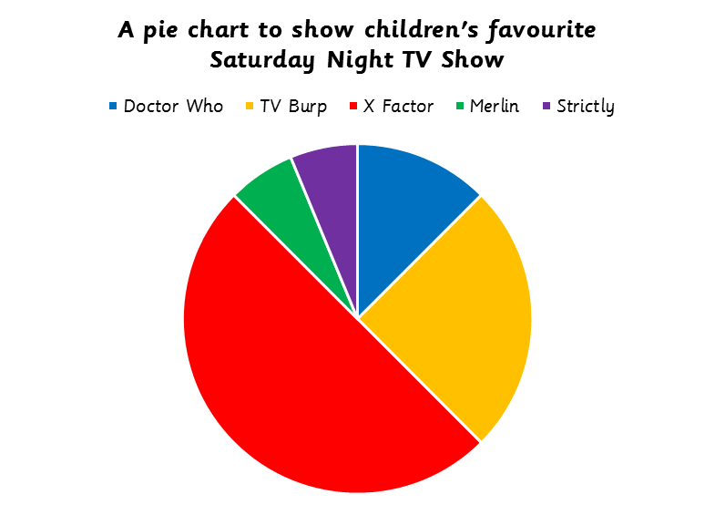 | This pie chart represents 80 children
 | 1. How many children chose TV burp as their favourite TV show?
 | 2. How many children chose The X Factor as their favourite TV show?
 | 3. How many more children chose Doctor Who than those who chose Strictly?
 | 4. How many more children chose The X Factor than those who chose Merlin?
 | 5. Which TV Show was the most popular?
 | 6. Which TV Shows were the least popular?

This pie chart represents 80 children
1. How many children chose TV burp as their favourite TV show?
2. How many children chose The X Factor as their favourite TV show?
3. How many more children chose Doctor Who than those who chose Strictly?
4. How many more children chose The X Factor than those who chose Merlin?
5. Which TV Show was the most popular?
6. Which TV Shows were the least popular?

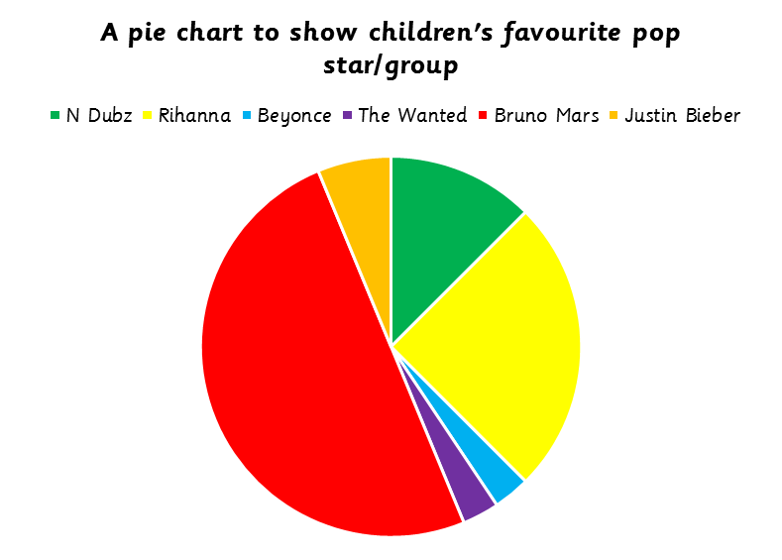 | This pie chart represents 32 children
 | 1. How many children chose Bruno Mars as their favourite pop star/group?
 | 2. How many children chose Beyonce as their favourite pop star/group?
 | 3. How many more children chose Rihanna than those who chose The Wanted?
 | 4. What was the difference in popularity between N Dubz and Justin Bieber?
 | 5. How many children chose Bruno Mars, Justin Bieber and Rihanna altogether?
 | 6. Write one fact that you know from looking at this pie chart

This pie chart represents 32 children
1. How many children chose Bruno Mars as their favourite pop star/group?
2. How many children chose Beyonce as their favourite pop star/group?
3. How many more children chose Rihanna than those who chose The Wanted?
4. What was the difference in popularity between N Dubz and Justin Bieber?
5. How many children chose Bruno Mars, Justin Bieber and Rihanna altogether?
6. Write one fact that you know from looking at this pie chart

