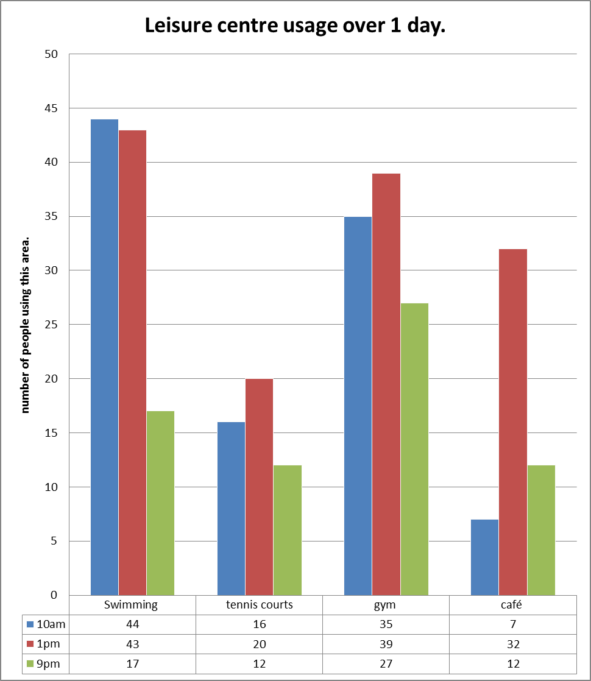

Leisure centre usage bar chart.

- What activity is the most popular?
- What time of day is busiest in the Leisure Centre?
- How many more people were swimming at 10am than at 9pm?
- Why do you think the café was busiest at 1pm?
- How many people were using the Leisure Centre at 1pm?
- How many more people were using the swimming pool than the gym at 10am?

- If you took another set of results at 5pm what do you imagine the results would look like?
Write a table showing the results (you have selected) at 5pm and then plot them on your own bar chart.

- What other useful information might the Leisure Centre want to collect? Can you think of different categories – maybe giving more information about the type of people using the Centre.

