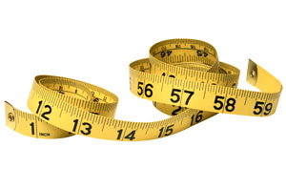  Measuring Tape  (Measures 1m/100cm) | 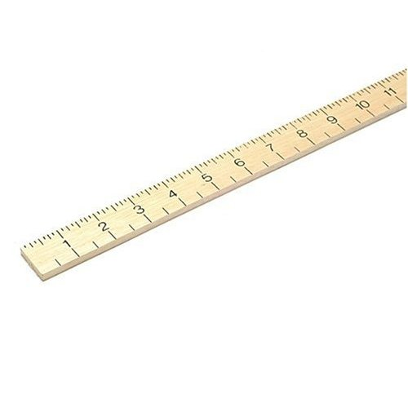  Metre Rule  (Measures 1m/100cm) | 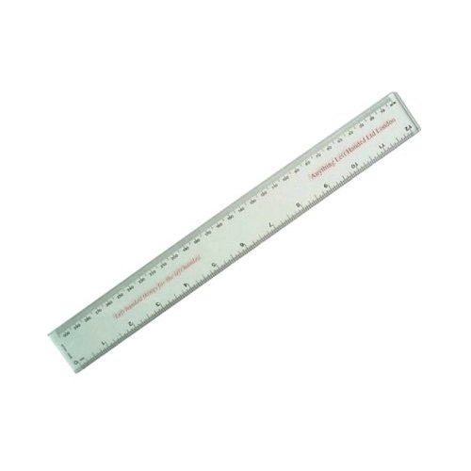  Ruler  (Measures 30cm/300mm) | 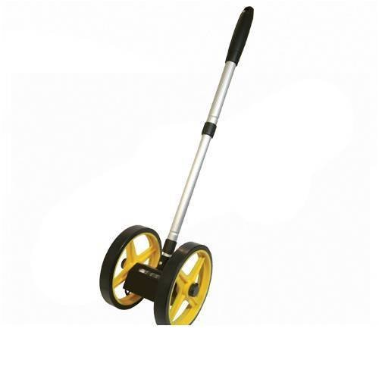  Click Wheel  (Measures 1m/100cm)

Measuring Tape  (Measures 1m/100cm) | Metre Rule  (Measures 1m/100cm) | Ruler  (Measures 30cm/300mm) | Click Wheel  (Measures 1m/100cm)

