Can you show Little Red Riding Hood the directions to Grandma’s cottage? The first one has been done for you.
N
W E
S
 |  |  |  | 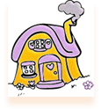
 | 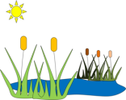
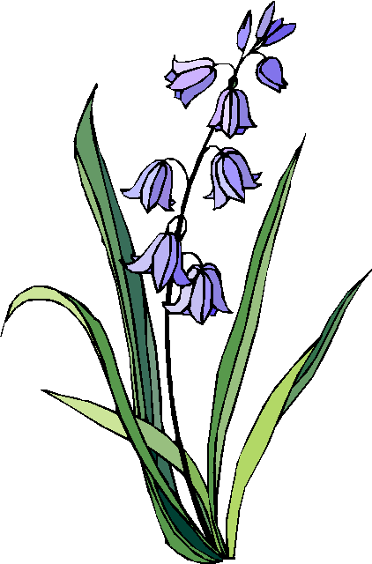

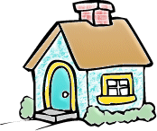 |  |  |  | 
 |  |  |  |  | 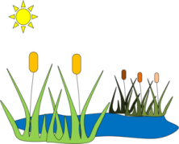
W1

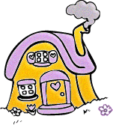Little Red Riding Hood’s house Grandma’s Cottage

