share
divide
equal groups of

subtract
take away
less than
minus
difference
count back

add
plus
more
altogether
sum
total
count on

times
multiply
lots of
product
groups

Maths Mat
Number Bonds to 10

0 + 10 6 + 4
1 + 9 7 + 3
2 + 8 8 + 2
3 + 7 9 + 1
4 + 6 10 + 0
5 + 5
Place Value
HTh TTh Th H T U

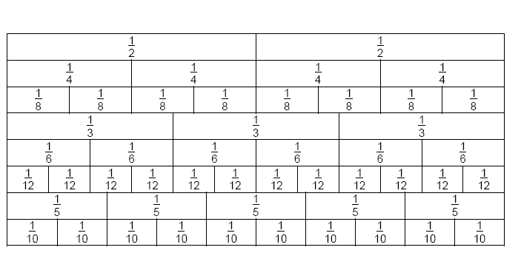
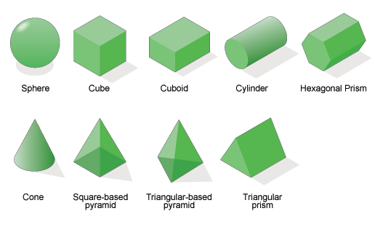
1 | 2 | 3 | 4 | 5 | 6 | 7 | 8 | 9 | 10
11 | 12 | 13 | 14 | 15 | 16 | 17 | 18 | 19 | 20
21 | 22 | 23 | 24 | 25 | 26 | 27 | 28 | 29 | 30
31 | 32 | 33 | 34 | 35 | 36 | 37 | 38 | 39 | 40
41 | 42 | 43 | 44 | 45 | 46 | 47 | 48 | 49 | 50
51 | 52 | 53 | 54 | 55 | 57 | 57 | 58 | 59 | 60
61 | 62 | 63 | 64 | 65 | 66 | 67 | 68 | 69 | 70
71 | 72 | 73 | 74 | 75 | 76 | 77 | 78 | 79 | 80
81 | 82 | 83 | 84 | 85 | 86 | 87 | 88 | 89 | 90
91 | 92 | 93 | 94 | 95 | 96 | 97 | 98 | 99 | 100



Fraction wall
5
sides
6
sides
8
sides
10
sides
3D
shapes
2D
shapes
circle | oval | triangle | square | rectangle
pentagon | hexagon | heptagon | octagon | decagon

1
side

3
sides
4
sides
4 sides
7
sides
1
side
2D shapes

Triangle-based
pyramid

¼ of 8 = 2
½ of 6 = 3

numerator – number that represents part of a
whole.
⅓ of 12 = 4
1/5 of 10 = 2
denominator – number that represents a whole.
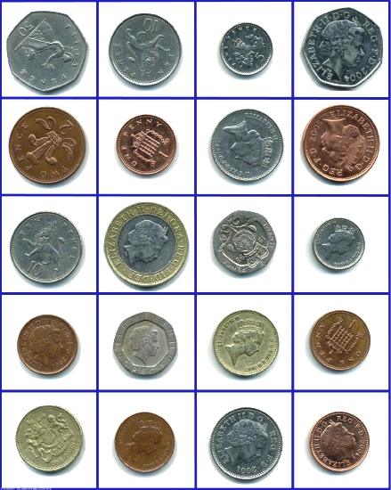
Seasons
Spring
March, April &May,
Summer
June, July &August
Autumn
September, October & November
Winter
December, January & February
X | 1 | 2 | 3 | 4 | 5 | 6 | 7 | 8 | 9 | 10
1 | 1 | 2 | 3 | 4 | 5 | 6 | 7 | 8 | 9 | 10
2 | 2 | 4 | 6 | 8 | 10 | 12 | 14 | 16 | 18 | 20
3 | 3 | 6 | 9 | 12 | 15 | 18 | 21 | 24 | 27 | 30
4 | 4 | 8 | 12 | 16 | 20 | 24 | 28 | 32 | 36 | 40
5 | 5 | 10 | 15 | 20 | 25 | 30 | 35 | 40 | 45 | 50
6 | 6 | 12 | 18 | 24 | 30 | 36 | 42 | 48 | 54 | 60
7 | 7 | 14 | 21 | 28 | 35 | 42 | 49 | 56 | 63 | 70
8 | 8 | 16 | 24 | 32 | 40 | 48 | 56 | 64 | 72 | 80
9 | 9 | 18 | 27 | 36 | 45 | 54 | 63 | 72 | 81 | 90
10 | 10 | 20 | 30 | 40 | 50 | 60 | 70 | 80 | 90 | 100

50p 10p 5p £00.50
2p 1p £00.10 £00.02
10p £2.00 20p £00.05
Days of the week
Sunday
Monday
Tuesday
Wednesday
Thursday
Friday
Saturday
Months of the year
January
February
March
April
May
June
July
August
September
October
November
December
1p £00.20 £1.00 £00.01
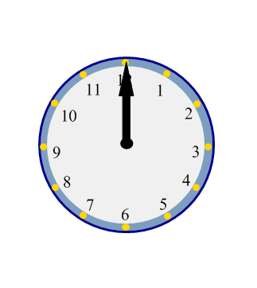
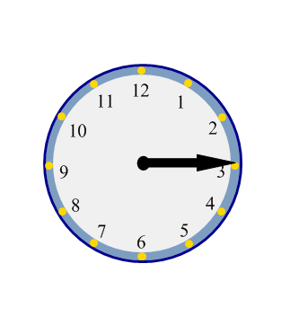
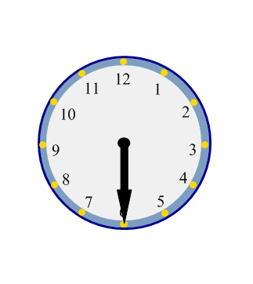
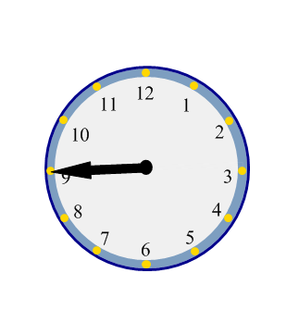

o’clock
quarter
past
half past
quarter
to
60 seconds…1 minute 2 weeks…1 fortnight
60 minutes…1 hour 4 weeks…1 month
24 hours…1 day 52 weeks…1 year
7 days…1 week 12 months…1 year
0 – zero 15 - fifteen
1 – one 16 - sixteen
2 – two 17 - seventeen
3 – three 18 - eighteen
4 – four 19 - nineteen
5 – five 20 - twenty
6 – six 30 - thirty
7 – seven 40 - forty
8 – eight 50 - fifty
9 – nine 60 - sixty
10 – ten 70- seventy
11 – eleven 80 - eighty
12 – twelve 90 - ninety
13 – thirteen 100 -one hundred
14 – fourteen 1000-one thousand
100p 1p 10p

