Can you measure in cubes?

Using the multilink cubes, measure things from around the classroom carefully, draw your item and put your answer in the box.

cubes

cubes

cubes

cubes

cubes

cubes

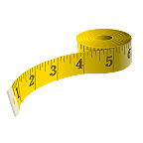
Can you measure in cm’s?

Using a tape measure OR a ruler, measure things from around the classroom carefully, and put your answer in the box.

cm

cm

cm

cm

cm

cm

cm

cm

cm

Did you find any surprises? What were they?

