Name : _________________Year : 4 5 6 Room : 1 8 14 15

Level 2
Objective 1 : Length, Mass, Capacity.
Length | - Rule lines of these measurements.  (a) 6cm  - 67mm  - 8.5cm  (d) 59mm
Mass | - Use this information to answer the following questions.  Susan: 20kg Simon: 23kg Sarah: 27kg Stan: 18kg  - Who is the heaviest? ________________  - Order the weights from heaviest to lightest ___, ___, ___, ___  - What is the combined weight of the girls? ____________  - How many kgs would Sam have to gain to be the same weight  as Sarah? ___________
Capacity | - These containers have the following amount of water in them.  20L 4 L 2L 12L  Drum Basin Jug Bucket  - How many jugs will fill a basin? _______  - How many basins will fill a drum? _______  - How many jugs will fill a bucket? _____  - How many jugs will fill ½ a drum? _____
Objective 2 Give Change for sums of money
 | $1.55 |  |  |  | $0.95 |  |  |  |  |  |  | $1.80 |  |  |  |  |  |  | $2.50
- How much change from $2.00 if I bought a hamburger? _______

- How much change from $5.00 if I bought an ice cream? _______

- How much change from $2.00 if I bought fries? _______

(d) How much change from $10.00 if I bought everything? _______

Objective 3 Show sums of money in different combinations of coins and notes.
 | Item | Cost |  |  |  | $5.00 |  | $2.00 |  |  |  |  | $1.00 |  | .50c |  | .20c |  |  | .10c |  | .05c
 | Yoyo | $4.65 |  |  |  |  |  | 2 |  |  |  |  |  |  | 1 |  |  |  |  | 1 |  | 1
(a) | Hat | $14.30
(b) | Toy | $7.65
(c) | Book | $9.95
(d) | Ball | $12.70
Objective 4 | Read time, know minutes, hours, days, months, years.
(a) What is the time shown on the clock?  (b) Show twenty to four on the clock by putting the hands in the correct place. | 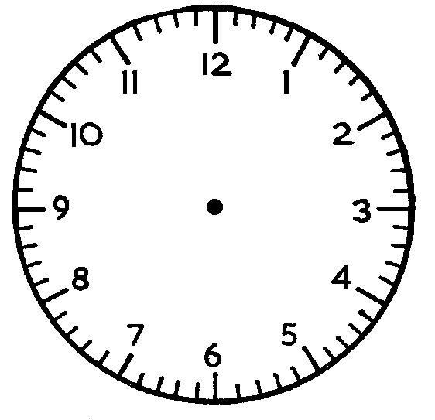
 | (c) Write the days of the week in order: Sunday,
- Write the months of the year in order:

( December, March, February, September, May, July, October, August, April, November, June, January)

Level 3
Objective 1 | Knowledge of Units of length, mass, area, volume and temperature
Length | - How many centimetres in a metre? ___________  - How many metres are in a kilometre? ______________  - How many millimetres in a centimetre? _______________  - How many centimetres in ½ a metre? _____________
Mass  0  1  2  3  4  5  0  1  2  3  4  5  0  1  2  3  4  5  0  1  2  3  4  5 | 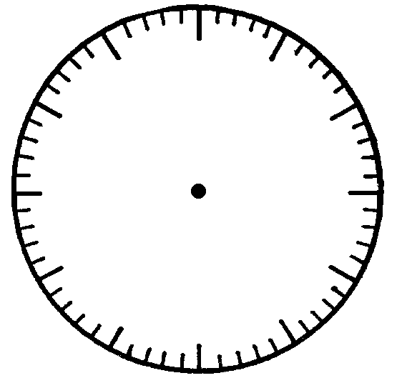
 | (a) kg |  | (b) kg |  |  |  |  |  |  |  |  | (c) kg |  |  |  |  |  |  | (d) kg
Area | Draw a 3cm by 2cm box.  - What does the perimeter of the box measure?  (b) What does the area of the box measure?
Volume | How many blocks in each shape?
 | (a) |  |  |  |  |  |  |  | (b)
 | (c) |  |  |  |  |  |  |  | (d)
Objective 2 | Read and Interpret time statements
These children took measurements of their performance over
three running distances.
50m (a) 100m (b) 200m (c)
 | Mary |  | 8.2 sec |  |  |  |  |  | 17sec |  |  |  |  |  |  | 40.3sec
 | Bill |  | 7.4sec |  |  |  |  |  | 15sec |  |  |  |  |  |  | 39.5sec
 | Tim |  | 9.2sec |  |  |  |  |  | 19sec |  |  |  |  |  |  | 38.1sec
 | Alex |  | 10.0sec |  |  |  |  |  | 22sec |  |  |  |  |  |  | 36.0sec
 | Sam |  | 8.3sec |  |  |  |  |  | 18sec |  |  |  |  |  |  | 39.2sec
 | Tina |  | 9.0sec |  |  |  |  |  | 20 sec |  |  |  |  |  |  | 38.0sec
 | Sally |  | 7.8sec |  |  |  |  |  | 16sec |  |  |  |  |  |  | 39.3sec
 | Put 1st, 2nd, 3rd, …. In the columns to show the finishing order in each race.
Objective 3 | Show analogue time as digital and vice versa.
Analogue to Digital
:
:
:
:
Digital to Analogue
6 : 30
11 : 45
3 : 40
8 : 05

Assessment Summary Comment if necessary
L2 Length | 1 | 2 | 3 | 4
L2 Mass | 1 | 2 | 3 | 4
L2 Capacity | 1 | 2 | 3 | 4
L2 Give Change | 1 | 2 | 3 | 4
L2 Comb. of Money | 1 | 2 | 3 | 4
L2 Time | 1 | 2 | 3 | 4
L3 Length | 1 | 2 | 3 | 4
L3 Mass | 1 | 2 | 3 | 4
L3 Area / Perimeter | 1 | 2 | 3 | 4
L3 Volume | 1 | 2 | 3 | 4
L3 Interpreting Time | 1 | 2 | 3 | 4
L3 Analogue to digital | 1 | 2 | 3 | 4
L3 Digital to Analogue | 1 | 2 | 3 | 4
Overall Assessment | 1 | 2 | 3 | 4

