How long is the train ?
Can you measure its length ?

How wide is the rhino ?
Can you measure its width ?
shorter
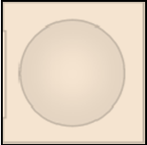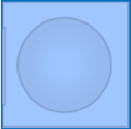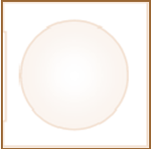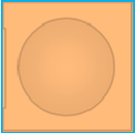

longer
Measure all the things on the table.
Make 2 groups.
Longer than 10 cubes.
Shorter than 10 cubes.
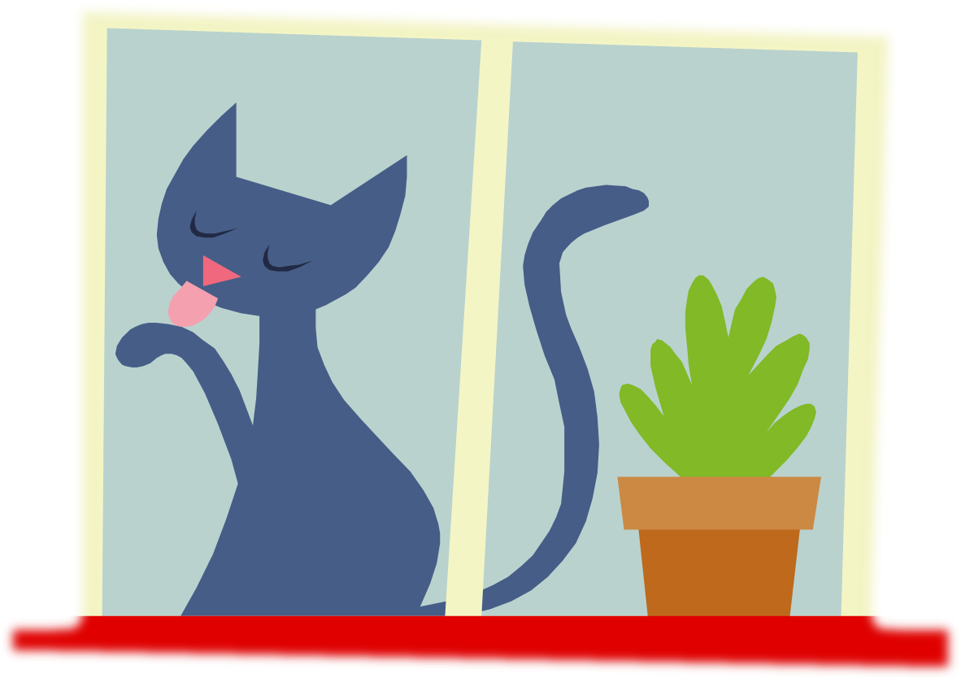
Measure the window to the nearest ruler length.

How much of the red ruler do you need ?
A little of it or a lot of it?

How many whole rulers are there?

How tall is the giraffe?

Can you measure its height?

