Measuring Length
Learning objective: To be able to measure length using non-standard units.
FIRST: Measure the objects using your hands.
THEN: Write the length in the table:
Object | Length/Number of hands
Book 
Table 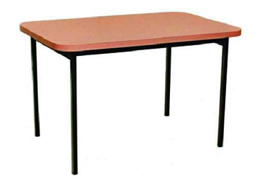
Sink 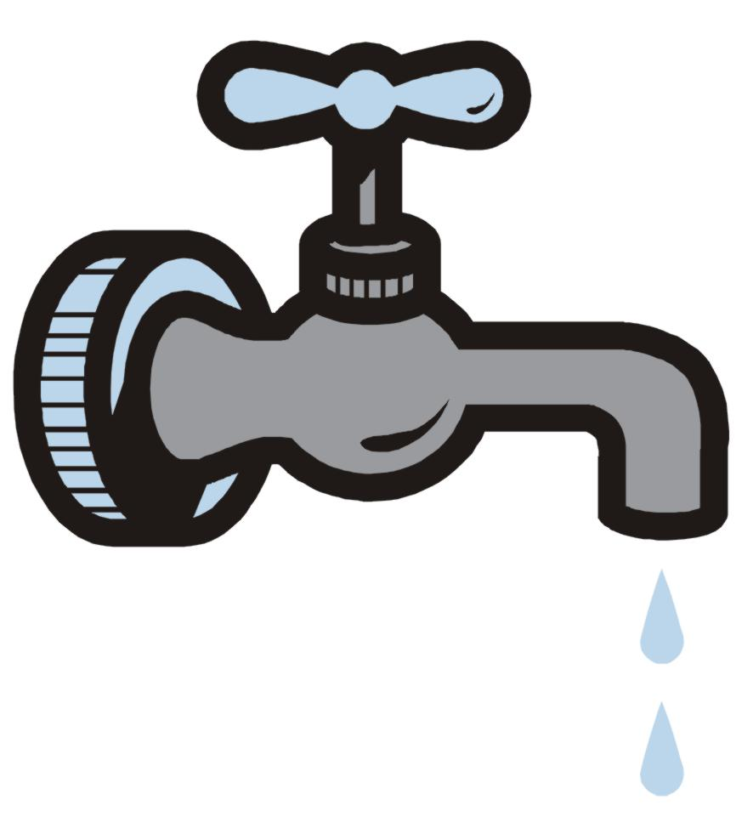
Your arm 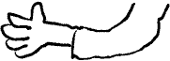

FINALLY: Talk to your teacher about what you have found!
Measuring Length
Learning objective: To be able to measure length using non-standard units.
FIRST: In yours pairs, measure the length of each object using your hands.
Object | Length/How many hands?
Book
Seat
Table
Your arm
THEN: Write the length of the objects in the table.

FINALLY: Answer the questions below:
1. How long was your leg in pencils?__________________________
2. How long is the table in hands? __________________________

Object: | Length (cm)
Learning objective: To be able to measure length using standard units.

1. What was the longest object you found? _________________________
2. What was the shortest object you found? _________________________

