Money – Over a Pound

When the cost of something is over a pound we write a special way and we have a special symbol to say it is a pound. For example,

If a teddy cost one pound and twenty pence we would write it, £1.20.

If a toy car cost three pounds and ten pence we would write it,
£3.10.

Add up the coins sums and write them down, they will all be over a pound.

1. 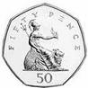 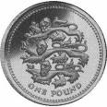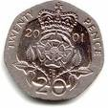 = ………..

2. 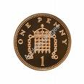 = …………

3. 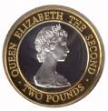 = …………

4. 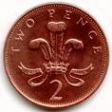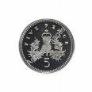 = ………….
5. 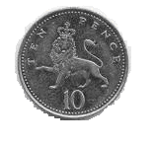 =………….

6. =………….

7. =……………

8. =…………..
9. = …………..

10.=………..

