A can of coke costs 20p and orange juice costs 10p.
How much would it cost to buy a can of cola and some orange juice?
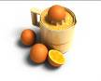

Tom’s mum sends him to buy a glass of milk for 20p, some orange juice for 10p and a can of cola for 20p.
She gives him 70p.
Is this enough?

I buy an apple for 10p, an orange for 20p, and a drink for 50p. How much do I spend in total?

Oranges cost 49p a kilo, apples 39p. I buy 1 kilo of each. How much do I spend?
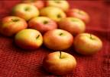

I buy 3 bananas for 35p each. How much do I spend altogether?


A pen costs 70p a pad 55p. How much do I spend in total?


My pencil costs 37p. I buy 4 of them. How much do I spend in total?


I buy 3 hair bands at 45p each. How much do I spend?

I buy 5 apples for 18p each. How much change would I get from £1.50?

I buy 7 rubbers 25p each. How much do I spend?
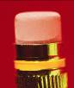

Eight pencils cost 80p. How much does each pencil cost?
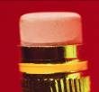

Ten sweets cost 50p. How much does each sweet cost?


Ten sweets cost £1. How much does each sweet cost?


