Money Word Problems

- Bob has £3.98. He wants to buy a book which costs £5.55. How much more money does he need?

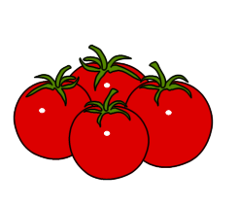
- I have £5.50 pocket money. I buy sweets which cost £1.39. How much money do I have left?

- Yesterday I went shopping. I bought some tomatoes for 79p and a bag of potatoes for £2.49. How much did I spend altogether?

- Rachel has £6.15. She wants to buy a top that costs £10.99. How much more money does she need?


- I have just been Christmas shopping. I bought my sister a bag which sot £7.10 and my brother a watch which cost £12.49. How much did I spend on Christmas presents?

- I have £10.00 to spend on a haircut. However, the haircut only costs me £8.36. How much money do I have left?

