Number bonds to 10

0 and 10(flap elbows)
My pet hen

1 and 9(thumbs up)
Now I’m fine

2 and 8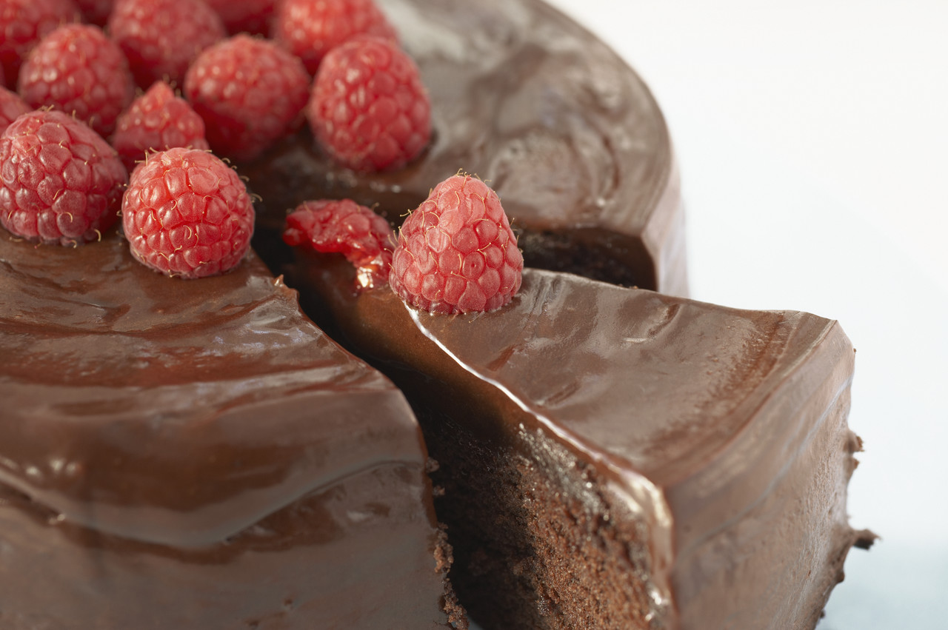(mime eating)
cake on a plate

3 and 7(flap wings)
Angels in heaven

4 and 6 (mime juggling)
I like tricks

5 and 5(BIG smile)
Glad I’m alive

6 and 4(point and wag finger)
That’s the law

7 and 3 (arm round Friend)
You and me

8 and 2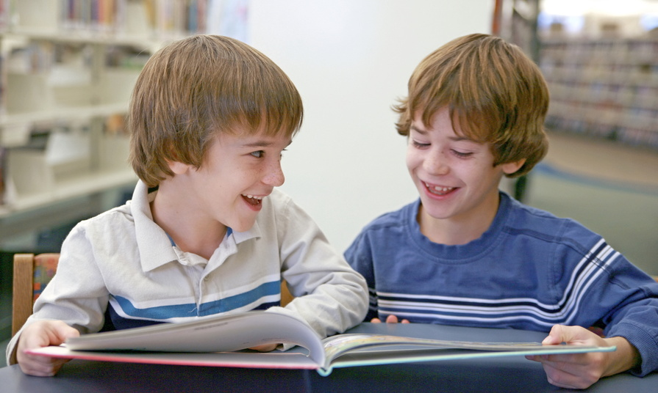(high five a friend)
I like you

9 and 1(both arms up high)
Let’s have fun

10 and 0 (superman pose)
I’m a hero
Number bonds to 100

0 and 100
Number bonds we dread

10 and 90
Mum in her nighty

20 and 80
Crazy old lady

30 and 70
We’re learning maths cleverly

40 and 60
Magic always tricks me

50 and 50
That’s pretty nifty

60 and 40
All the class were naughty

70 and 30
My knees are dirty

80 and 20
Have you got plenty?

90 and 10
Shall we start again?

100 and 0
I’m a maths hero!

