Number Sequences and Place Value
Missing Numbers
345, 347,______,______353, _____ ,_____, _____, ______
236, 240, _____, _____, _____ , ______ , ______, ______
172, 182, _____,_____,_____,_____, 232, ______
341, 361, _____,_____, 421, ______, ______, ______
520, 535,_____, 565, _____, ______, ______, ______
Write your own sequence. Each number must have 3 digits.
___________ ,_________ ,__________ ,__________ ,_________ ,________
___________ ,_________ ,__________ ,__________ ,_________ ,________
Oh no, I’ve forgotten my number!!
Help the people to remember their numbers.
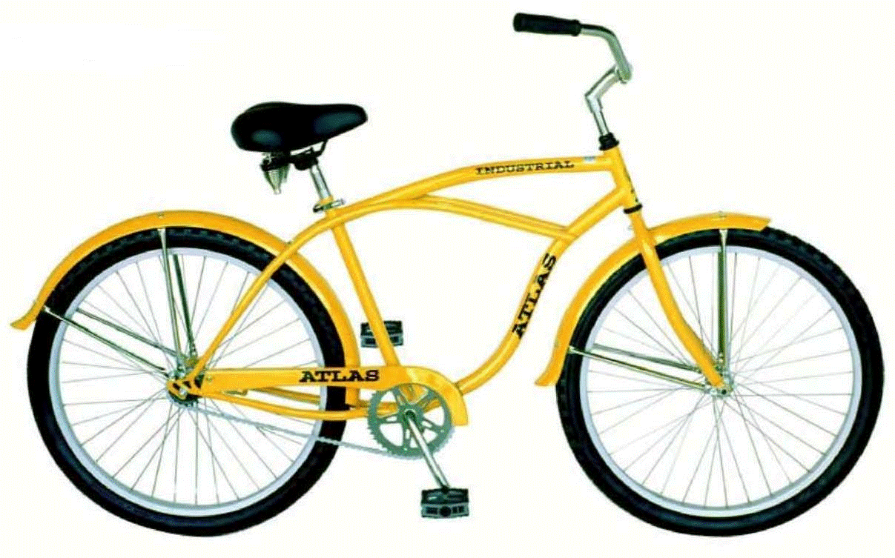
My bike is locked. My combination includes these numbers
526. It is the smallest even number.
What is my combination ? ___ ___ ___
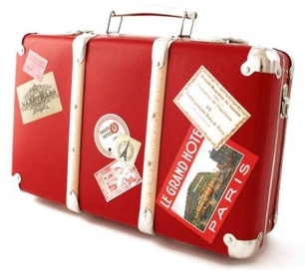
My suitcase is locked and I need to get my clothes packed
for holiday. The numbers are 892. It is the biggest odd
number. What is my combination ? ___ ___ ____
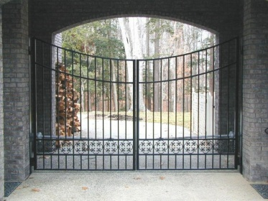
My gate is locked . I know the number begins with a 3, but
I can’t remember the order of the numbers. The other
numbers are 519. It is the biggest number. What is my combination?
3 ___ ___ ___

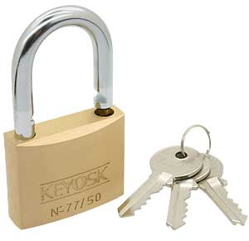
My padlock has a combination. It is 4 digits and it is the
smallest possible number using 8657.
What is my combination ? ____ ____ ____ ___

