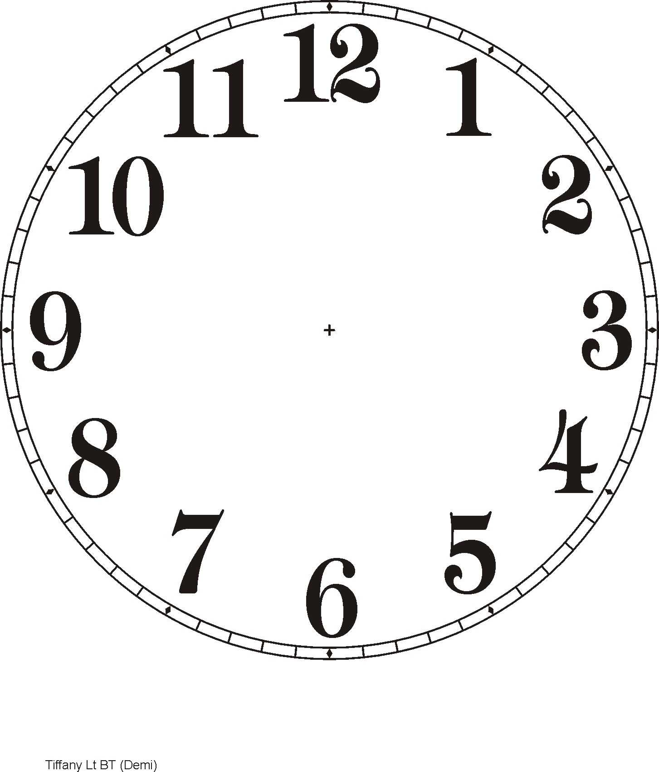  I have  Who has  3 o’clock? | I have  Who has  12 o’clock?
I have  Who has  4 o’clock? | I have  Who has  half past 1?
I have  Who has  5 o’clock? | I have  Who has  half past 6?
I have  Who has  7 o’clock? | I have  Who has  half past 9?
I have  Who has  10 o’clock? | I have  Who has  half past 11?
I have  Who has  1 o’clock? | I have  Who has  2 o’clock?
I have  Who has  6 o’clock? | I have  Who has  half past 7?
I have  Who has  8 o’clock? | I have  Who has  half past 2?
I have  Who has  half past 3? | I have  Who has  half past 4?
I have  Who has  10 o’clock? | I have  Who has  1 o’clock?

