Multiples

Multiples are numbers in the times table of your given number e.g. 20, 30, & 40 are multiples of 10. Can you label these octopuses tentacles with some of their multiples?

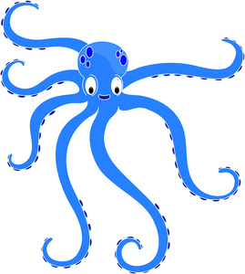

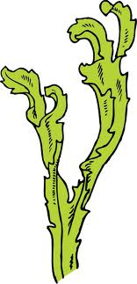

Multiples

Multiples are numbers in the times table of your given number e.g. 20, 30, & 40 are multiples of 10. Can you label these octopuses tentacles with some of their multiples?

Multiples

Multiples are numbers in the times table of your given number e.g. 20, 30, & 40 are multiples of 10. Can you label these octopuses tentacles with some of their multiples?

Multiples

Multiples are numbers in the times table of your given number e.g. 20, 30, & 40 are multiples of 10. Can you label these octopuses tentacles with some of their multiples?

Multiples

Multiples are numbers in the times table of your given number e.g. 20, 30, & 40 are multiples of 10. Can you label these octopuses tentacles with some of their multiples?

Factors

Factors are numbers you multiply together to make your start number e.g. the factors of 6 are 2, 3, 1 and 6.
Can you fill in the factors of these numbers on the turtles back?

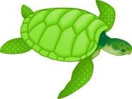
24
12
20

Factors

Factors are numbers you multiply together to make your start number e.g. the factors of 6 are 2, 3, 1 and 6.
Here are some blank turtles for you to choose your own numbers and their factors.

