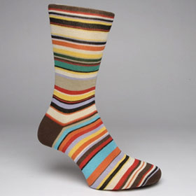
7 is _____

5 is _____

6 is _____

3 is _____
8 is _____

4 is _____

11 is _____

