Time - One hour later
L.O: To use units of time (minutes and hours). To read the time to the quarter hour.
Draw the hands on the clock to show 1 hour later than the given times. Then write the new time in words.

half past 3 quarter past 7 half past 6
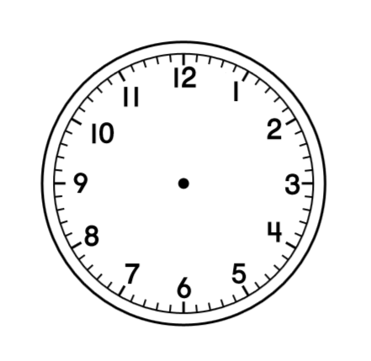
1. ________________________ 2. ________________________ 3. ________________________

half past 9 quarter to 4 quarter past 11
4. ________________________ 5. ________________________ 6. ________________________

quarter to 1 quarter past 8 quarter to 2
7. ________________________ 8. ________________________ 9. ________________________
Time - One hour later
L.O: To use units of time (minutes and hours). To read the time to 5 minute intervals.
Draw the hands on the clock to show 1 hour later than the given times. Then write the new time in words.

10 minutes past 3 25 minutes past 6 15 minutes to 11
1. ________________________ 2. ________________________ 3. ________________________

20 minutes past 10 5 minutes past 7 10 minutes past 8
4. ________________________ 5. ________________________ 6. ________________________

15 minutes past 1 25 minutes past 2 15 minutes to 8
7. ________________________ 8. ________________________ 9. ________________________

