Name ___________________________________________________ Date _______________________________
LO: to draw and translate shapes on a co-ordinate plane
On the grid below, draw your own shape (don’t make it too complicated shapes with straight lines in them work best) and translate it. Write down the co-ordinates of your original shape. Write down how you are planning to move it (e.g. 2 up and 2 to the right) and then draw it again and write down the new co-ordinates.
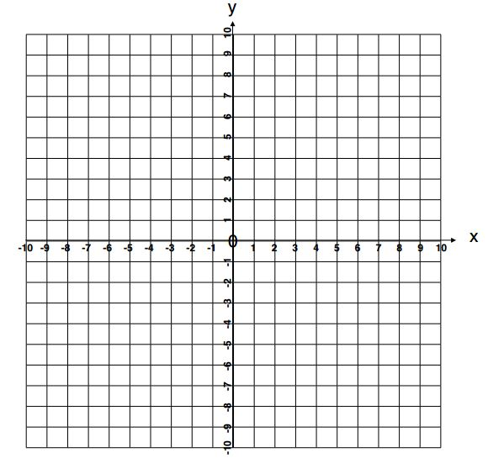
The co-ordinates of the original shape are: __________________________________________________________________________________________

I moved it: __________________________________________________________________________________________

The shape’s new co-ordinates are: __________________________________________________________________________________________
The co-ordinates of the original shape are: __________________________________________________________________________________________

I moved it: __________________________________________________________________________________________

The shape’s new co-ordinates are: __________________________________________________________________________________________

