Name:_______________ Class:_____ Date: _______

LO: I can calculate and remember the addition and subtraction pairs that make 100.

Instructions:
Using 2 dice with your partner throw 2 numbers, one number is going to create the tens and the other the units (6 and 3 = 63).
Write the number you throw in the boxes on your work sheet, and then calculate the addition or subtraction questions.
6 | 3 | + |  |  | = | 100
 |  | + |  |  | = | 100
 |  | + |  |  | = | 100
 |  | + |  |  | = | 100
 |  | + |  |  | = | 100
 |  | + |  |  | = | 100
 |  | + |  |  | = | 100
 |  | + |  |  | = | 100
 |  | + |  |  | = | 100
 |  | + |  |  | = | 100
 |  | + |  |  | = | 100
Teacher Pupil
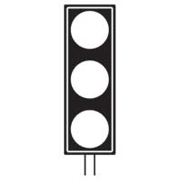

100 | - | 6 | 3 | =
100 | - |  |  | =
100 | - |  |  | =
100 | - |  |  | =
100 | - |  |  | =
100 | - |  |  | =
100 | - |  |  | =
100 | - |  |  | =
100 | - |  |  | =
100 | - |  |  | =
100 | - |  |  | =

Teacher Pupil

