Name ________________________ Date _______________________
You need to plan what your guests will have to eat and drink at your party! Use the menus to work out the costs for the following party plates.

1 sandwich
1 bowl of crisps
3 cookies
1 coke
Total cost =
2 slices of pizza
1 bowl of chips
ice cream
milkshake
Total cost =

1 bowl of rice
2 ribs
1 slice of cake
water
Total cost =

2 sandwiches
2 drumsticks
1 fruit salad
orange juice
Total cost =

1 sandwich
4 sausage rolls
2 slices watermelon
coke
Total cost =

2 ribs
chips
3 cookies
milkshake
Total cost =

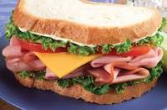
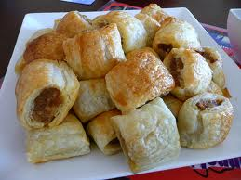
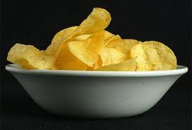
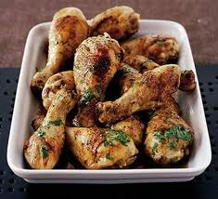
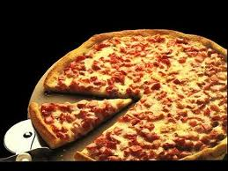
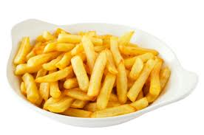
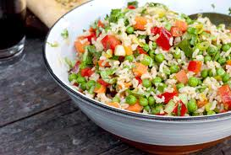
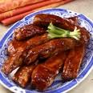
30p each
10p each
20p per bowl
15p each
30p per slice
45p per bowl
40p per bowl
25p each
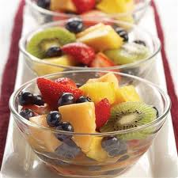
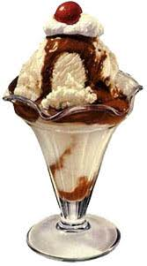


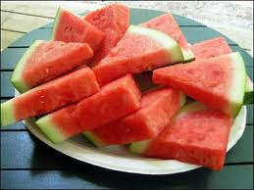

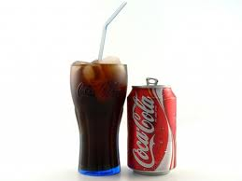


30p per bowl
40p per slice
20p each
30p per slice
50p each
50p each
50p each
80p each

0p each
Name ________________________ Date _______________________
Now you can decide what your guests will have at your party. What is the cheapest meal? Or the tastiest meal for under £2.00? What is the most expensive?

