Name: Class:
Mark /50

Percentages %

My comments:

My teacher’s comments:

Created by Mrs Shanks
A. Adam is struggling with his work. He understands his fractions and decimals but needs help with his percentages. Using your knowledge of decimals and fractions can you find the missing percentages?
Fraction | Decimal | Percentage %
1  100 | 0.01
1  20 | 0.05
1  10 | 0.1
1  5 | 0.2
1  4 | 0.25
1  2 | 0.5
3  4 | 0.75

/ 7 B. Now work out the following:
10% of :
50 = 80 = 100 = 130 =
25% of:
60 = 80 = 100 = 140 =
50% of:
60 = 12 = 100 = 140 =
/12
C. TRUE or FALSE
Read the following statements and decide if they are true or false. The first one has been done for you.
To work out 50% of a number you can divide it by 2. True

To work out 50% of a number you half it. __________________

75% is smaller than ½. __________________

75% is larger than ½. __________________

To work out 25% of a number you can divide it by 4 __________________

75% of 200 = 160 __________________

75% of 200 = 150 __________________

25% is equivalent to ¼. __________________

To work out 20% of a number you can divide it by 5. __________________

20% of 250 = 45 __________________

20% of 250 = 50 __________________ /10
D. Percentage Problems

A shop is having a 25% discount sale. Work out the new prices for the following items.
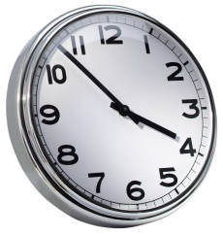
Necklace Watch Clock
£ 12.00 £8.80 £10.00

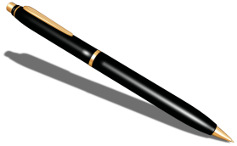 Pen £2.40 £456.00

Item | Original Price | 25% off | New Price
Necklace | £12.00 | £3.00 | £9.00
Watch | £8.80
Clock
Pen

Ring

/4

E.
Good news! These children have a 25% pocket money increase What will they now have to spend?

Name | Pocket Money | 25% | New amount
Adam | £8.00 | £2.00 | £10.00
Ben | £12.00 | £ | £
Jill | £5.40 | £ | £
Shabana | £5.00 | £ | £
Zain | £9.20 | £ | £

/4
F. If Carl has a 50% increase on £4.50 how much will he receive? Will it be more than Shabana?
______________________________________________________________

_________________________________________________________ /2

G. If Donna has a 75% increase in her allowance. How much will she receive if she currently has £4.40?
________________________________________________________________
/1
H. Below is the list of scores on a numeracy test. Fill in the missing information.

Name | Numeracy score  /20 | Percentage  %
Adam | 16
Ben |  | 95 %
Jill |  | 70%
Shabana | 18
Zain | 10
/5
I Now rearrange the list from 1st place to 5th.
Name | Position
 | 1st
/5

