Percentages
SALE 50% OFF EVERYTHING
Ball £ 8. 20 Bucket & spade £ 6.80 Jack in Box £4.60 Tricycle £ 10.40
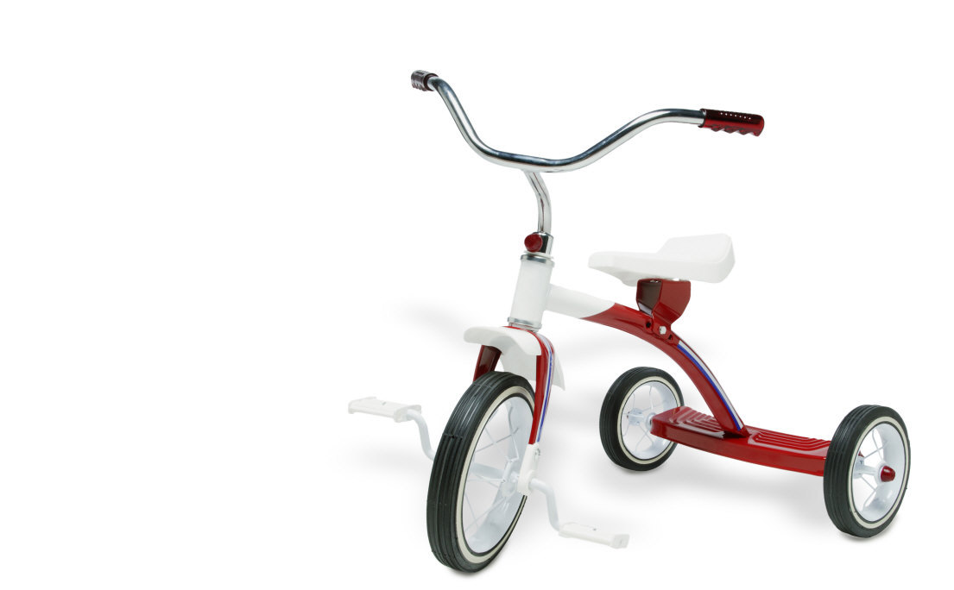


What price do I now pay for:-
*The ball ____________________ *The jack in box_________________

*The bucket and spade __________ *The tricycle____________________

SALE - 25% OFF EVERYTHING

Helmet football
£ 12 .00 £ 8 .00 binoculars trainers
£4.00 £ 16.00
What price do I now pay for:-

Helmet ________________ Binoculars ________________

Football _______________ Trainers __________________

FIND:-

25% of 20 = ______ 25% of 40 = ______

25% of 24 = ______ 25% of 28 = ______

Percentages – My Percentage Garden
Colour your garden using different percentages for at least 5 colours

10% ___________ 20% ____________

25% ___________ 15% ____________

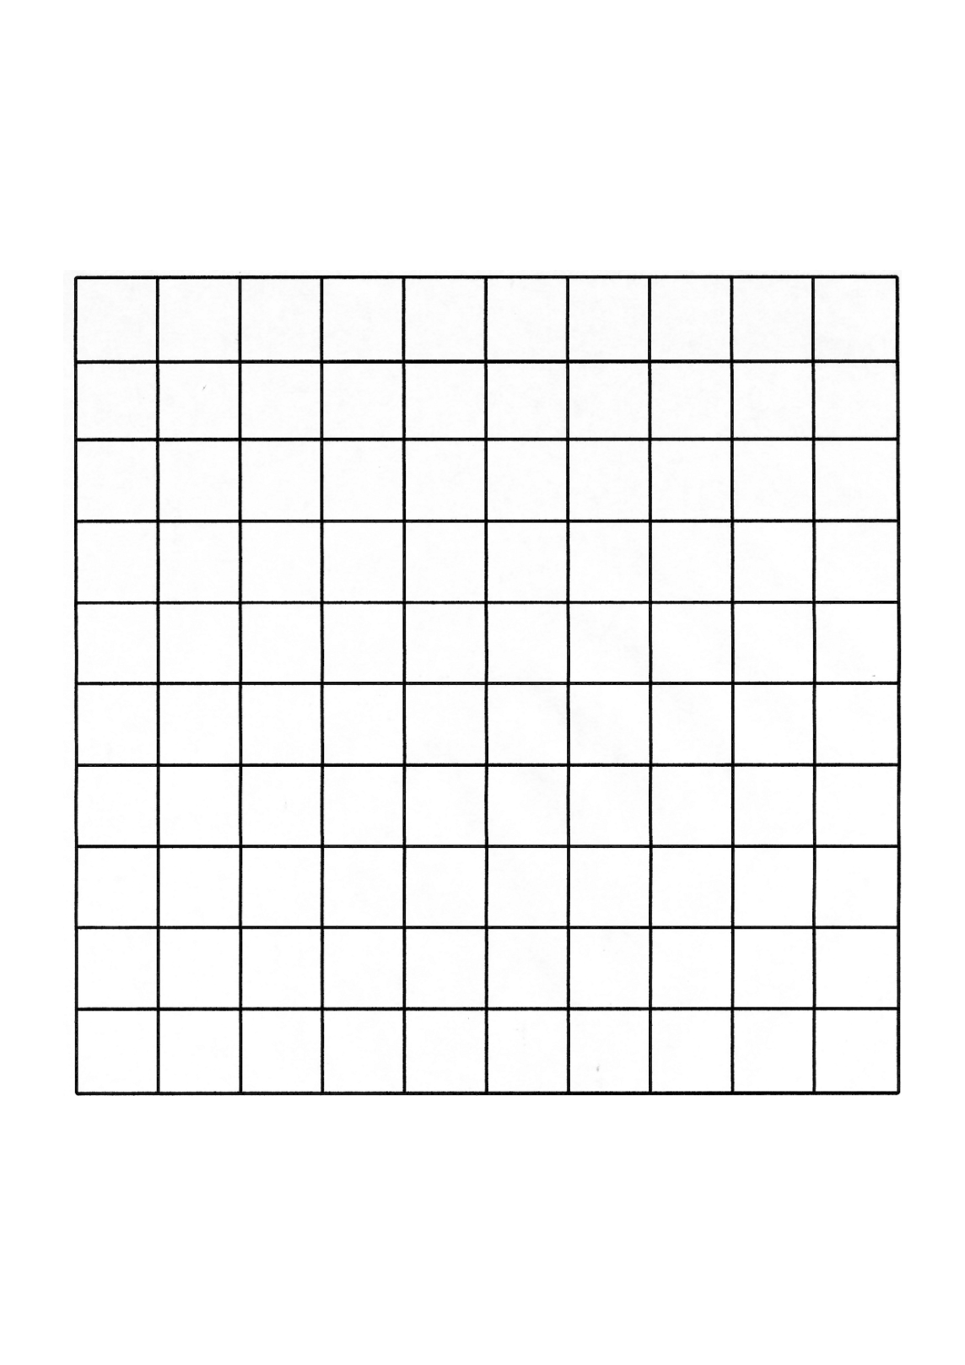
5% __________

Now make up 3 questions you could ask your partner about your garden.

*

*

*

Percentages of amounts
- Find
a) 20% of 35 = _____ b) 20% of 20 = _____

c) 20% of 30 = _____ d) 20% of 15 = _____

e) 20% of 25 = _____ f) 20% of 10 = _____

g) 20% of 45 = _____ h) 20% of 50 = _____

B) SHOPPING SALE 20% OFF EVERYTHING

Goggles
Flip-flops Swimsuit Trunks £9.00
£6.00 £7.00 £6.50
How much do I now pay for;-

a)Flip-flops _______ b)Swimsuit ______ c)Trunks ______d)Goggles______

- Calculate:-
a) 10% of £8.00 = ________ b) 10% of £12.00 = _________

c) 10% of £4.80 = ________ d) 10% of £11.40 = _________

e) 10% of £5.30 = ________ f) 10% of £15.00 = _________

D) SHOPPING 10 % DISCOUNT OFF ALL JEWELLERY
Watch ring necklace earrings
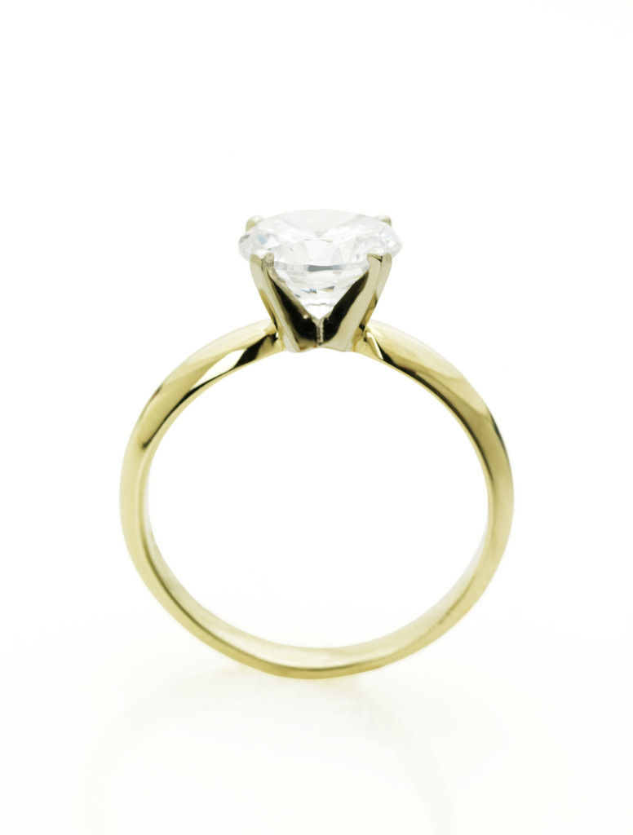

£20.00 £24.00 £75.00 £18.00
How much do I now pay for
Watch _______ ring _______ necklace _______ earrings _________

