PLACE VALUE
Roll a dice and put the numbers in the columns to make 2 numbers..
Hundreds | Tens | Ones

Hundreds | Tens | Ones
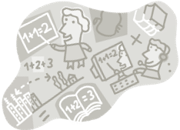

In your book:
- Write each number in words.
- Expand Each Number:
e.g. 356 = 300 +50+60
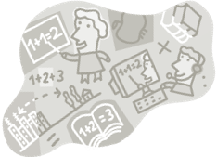
- Which number is the largest?
Write a number sentence using > or < to show this.
Extension: Put a 0 in the tens column each time

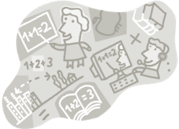
PLACE VALUE
Roll a dice and put the numbers in the columns to make 2 numbers.
Thousands | Hundreds | Tens | Ones

Thousands | Hundreds | Tens | Ones

In your books:
- Write out each of the numbers you have made in words
- Expand Each Number:
e.g. 356 = 300 +50+60
- Which number is the largest.
Write a number sentence using > or < to show this.

Extensions :a) Put a 0 in the tens column b) put a 0 in the hundreds column c) put a zero in the Tens and the Hundreds column.

