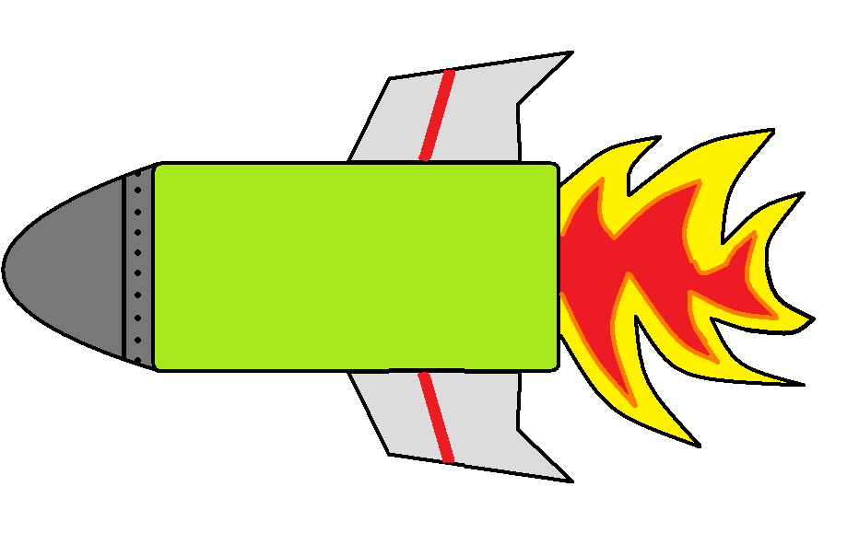
1
0

2
0

3
0

0
0

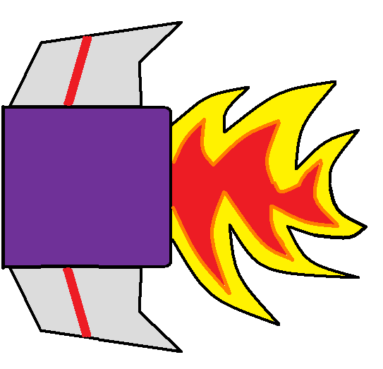
0

1

2

3

4

5

6

7

8

9

