How I planned the Year 4 Maths. (Same principle substitute the Year Group)
I am sorry if the writing on the pictures is a bit small but I wanted to put in as much of the web page as possible to stop you getting lost.

1) I started on the main page and selected maths. I found myself here http://www.standards.dfes.gov.uk/primaryframeworks/mathematics/
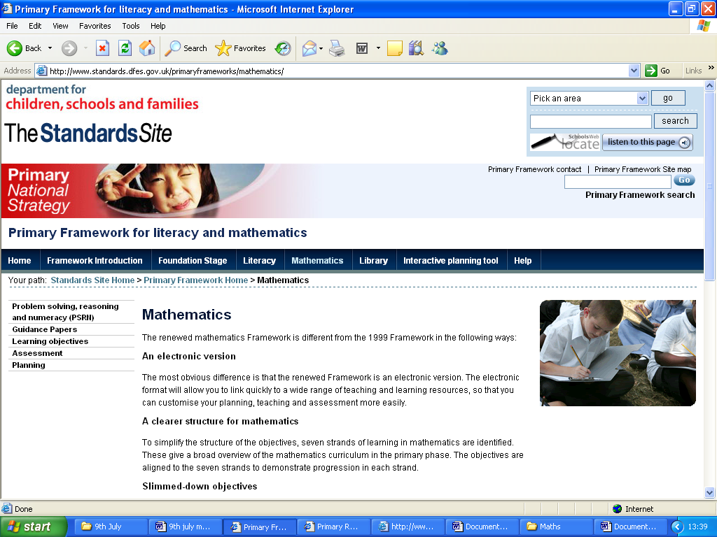

2) I then selected planning and found myself here
http://www.standards.dfes.gov.uk/primaryframeworks/mathematics/planning/
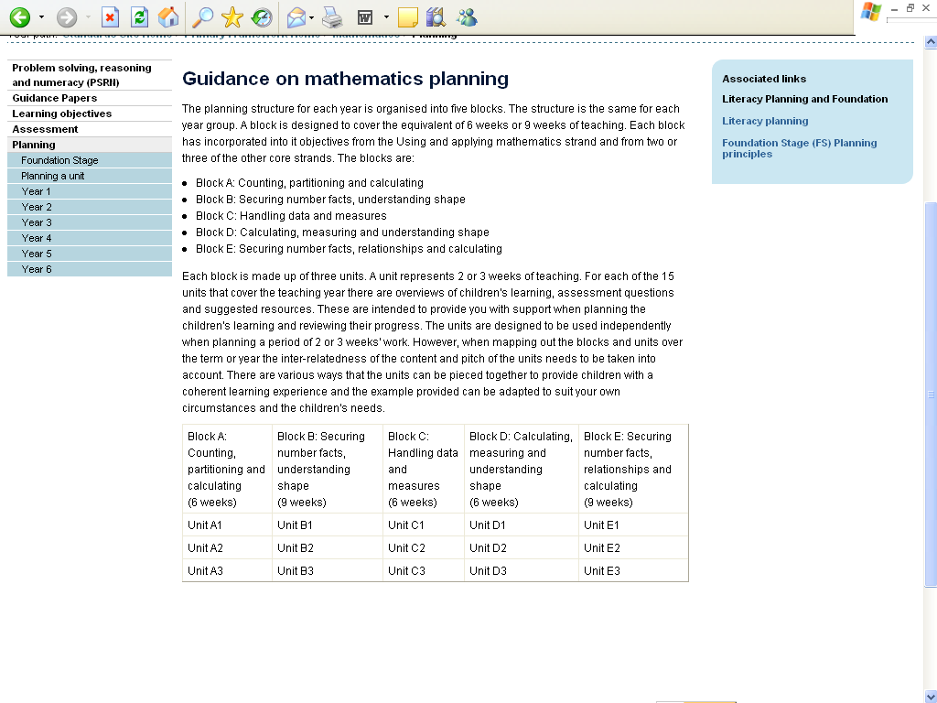

3) I then selected the Year group I wanted and found myself here-

http://www.standards.dfes.gov.uk/primaryframeworks/mathematics/planning/Year4/

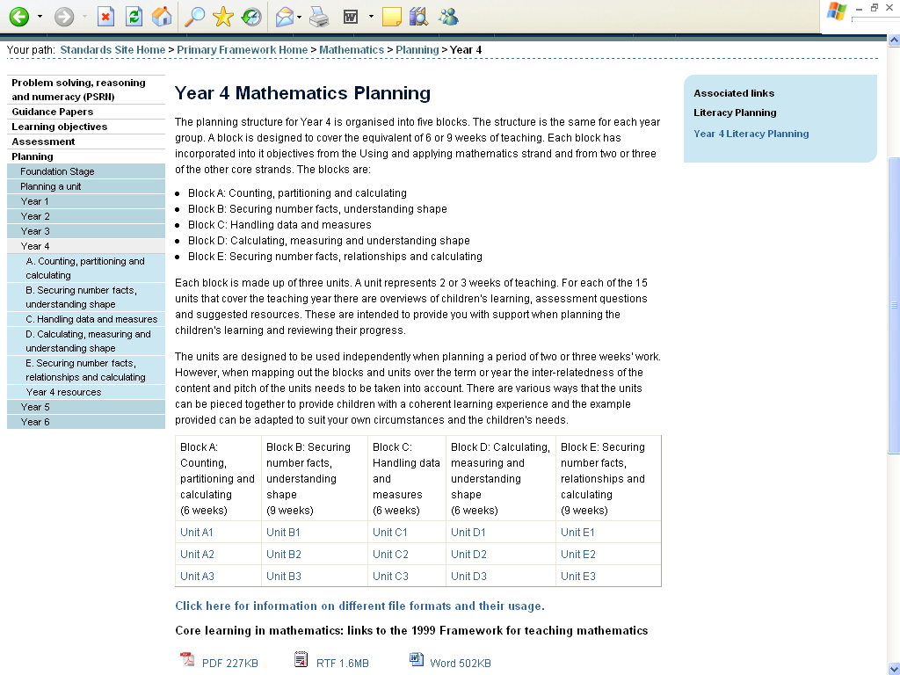
Save this page to your favourites as you will need it each time you plan.

4) I looked for the strand I wanted . This gives me my objectives for the unit. The page looked like this

http://www.standards.dfes.gov.uk/primaryframeworks/mathematics/planning/Year4/relationships/Unit3/
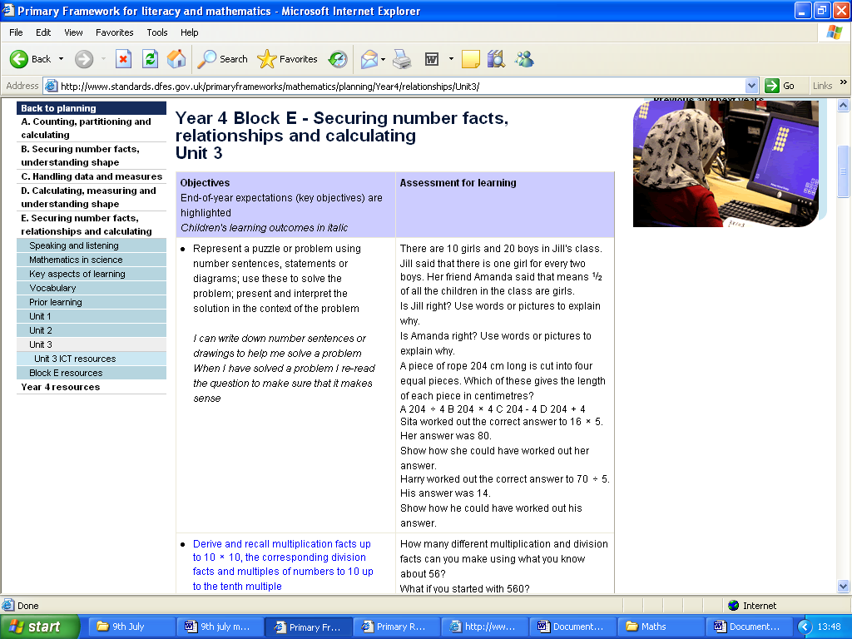

5) I then clicked on Block E resources to find the learning journey and there I could download what I needed. The next page looked like this;

http://www.standards.dfes.gov.uk/primaryframeworks/mathematics/planning/Year4/relationships/resources/
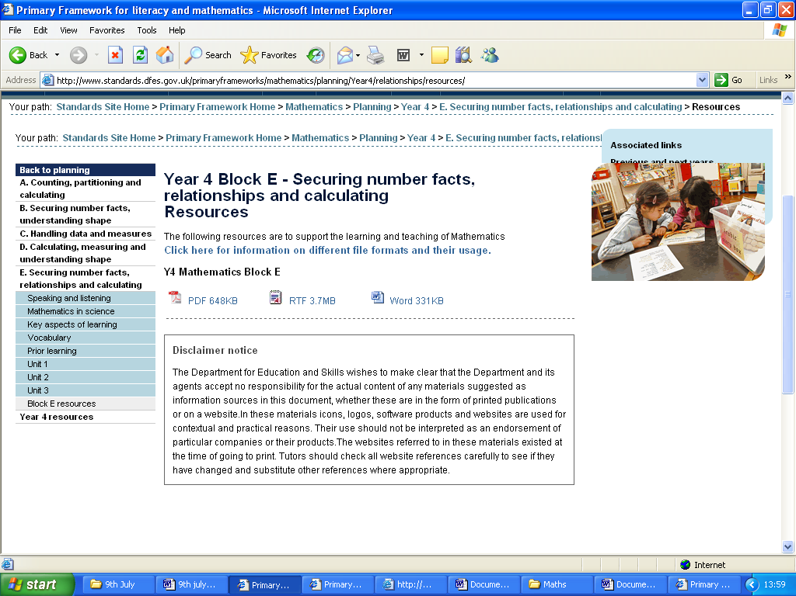
prior learning
Download your learning journey here

6) On this page I found links to speaking and listening, mathematics in science, key aspects of learning, vocabulary and Prior Learning.

I then clicked on the prior learning link to find a list of questions to ask the children before you plan, to give you a starting point and that looks like-

http://www.standards.dfes.gov.uk/primaryframeworks/mathematics/planning/Year4/relationships/priorlearning/
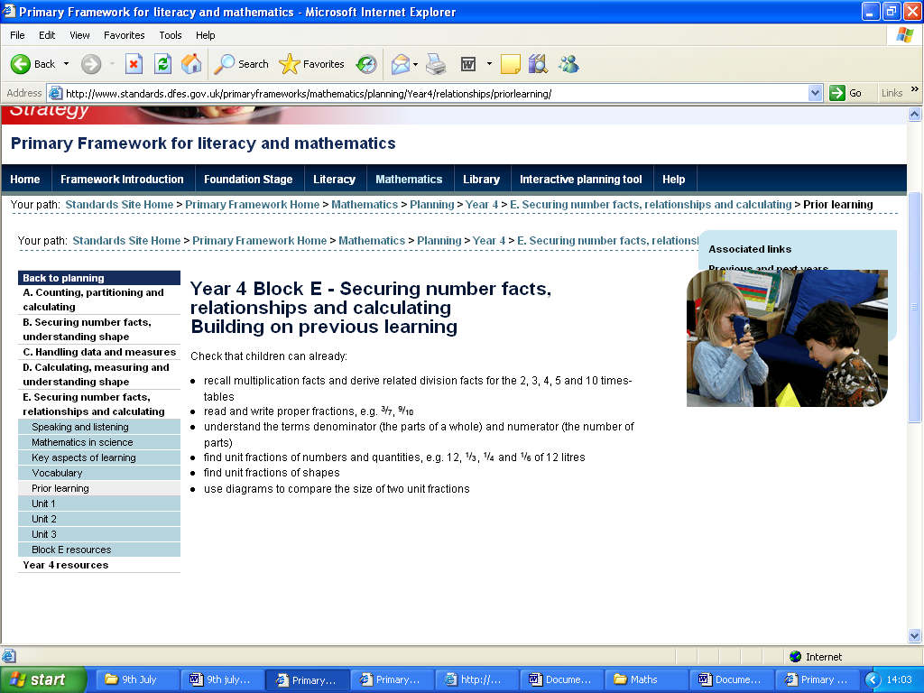

7) I then checked this against the pitch and expectation for the Year 4 group and so I clicked on resources and that looked like this

Found pitch and expectation here
http://www.standards.dfes.gov.uk/primaryframeworks/mathematics/planning/Year4/resources/
This shows me where the children are at but not where they should be, therefore I looked for Building on previous learning section.
Download your pupil expectations here
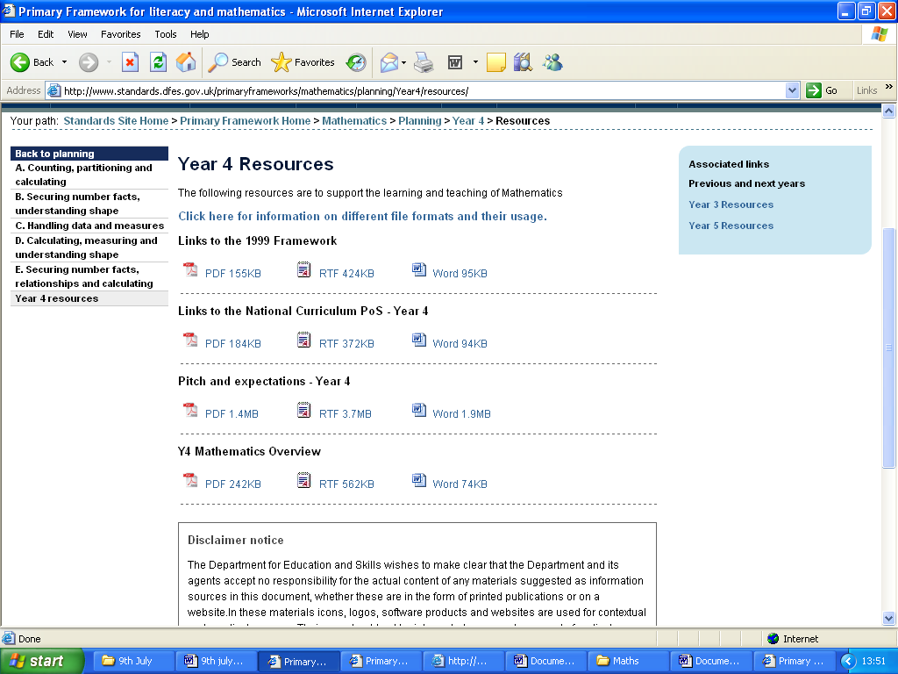

You then should have all your tools to plan your unit (I am a fallible being so if you are missing something don’t hesitate to pick me up on it).
The planning sheet I propose looks like this

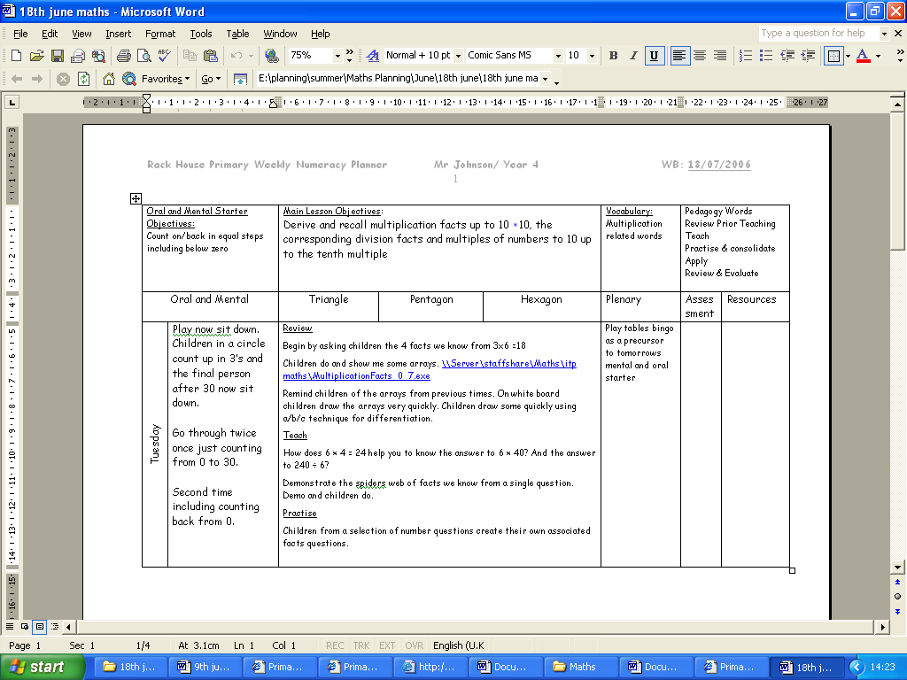
This is not set in stone and is just a starting point
Pedagogy words for reference in planning sequence

