Name………………………………………. Date:

LO: Position 2 digit numbers on a numberline.

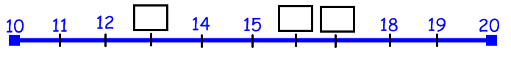

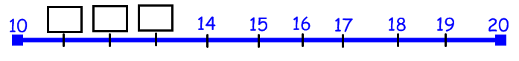

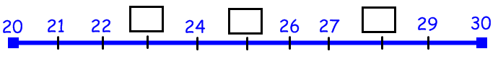

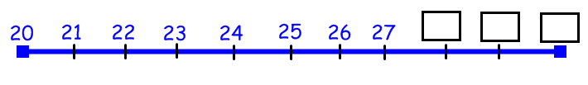

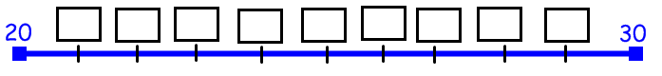

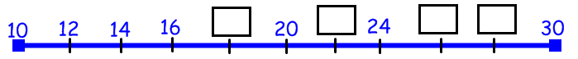

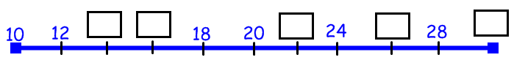

Name………………………………………. Date:

LO: Position 2 digit numbers on a numberline.

Name………………………………………. Date:

LO: Position 2 digit numbers on a numberline.

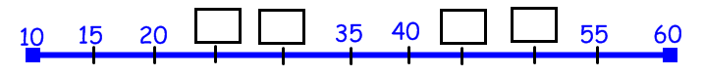

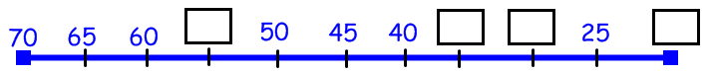

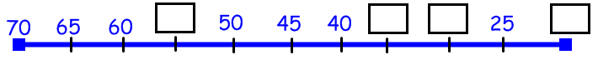
Name………………………………………. Date:

LO: Position 2 digit numbers on a numberline.

Name………………………………………. Date:

LO: Position 2 digit numbers on a numberline.

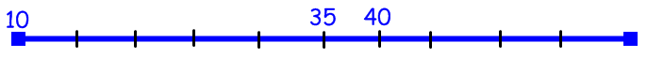

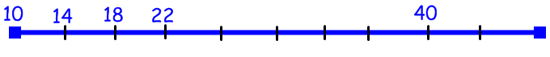

Find 3 different ways to complete this numberline.

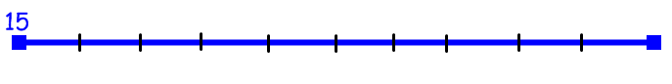

Name………………………………………. Date:

LO: Position 2 digit numbers on a numberline.

Find 3 different ways to complete this numberline.

