Group -
I can read a protractor
I can identify acute and obtuse angles
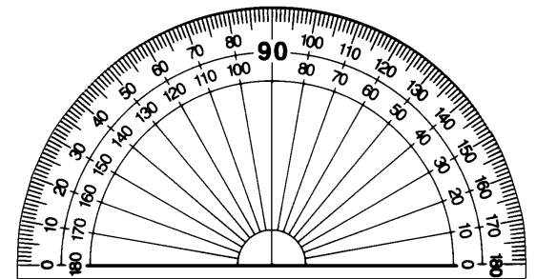

This protractor measures This protractor measures
acute
acute
obtuse
obtuse
It is It is

This protractor measures This protractor measures
acute
acute
obtuse
obtuse
It is It is

This protractor measures This protractor measures
acute
acute
obtuse
obtuse
It is It is
I can use a protractor to draw angles accurately
Remember to follow the drawn line to zero.
Remember what 90° looks like.

Estimate what 80° looks like.

Now use your protractor to draw it.

Estimate what 40° looks like.

Now use your protractor to draw it.

Extension: In your book draw and label some acute and some obtuse angles. Always estimate what it should look like so you can see if your drawn angle is sensible.

