Date ____________ WALT – read scales and record in kg

Draw the pointer on the scale to show the weight below.

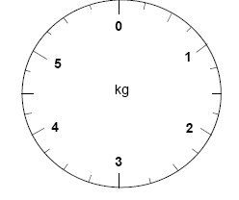
2kg 5kg 1kg

4kg 0kg 3kg

2½ kg 3½kg 4½kg

Date ____________ WALT – read scales and record in kg

Write the weights under the scales.

____kg ____kg ____kg

____kg ____kg ____kg

____kg ____kg ____kg

