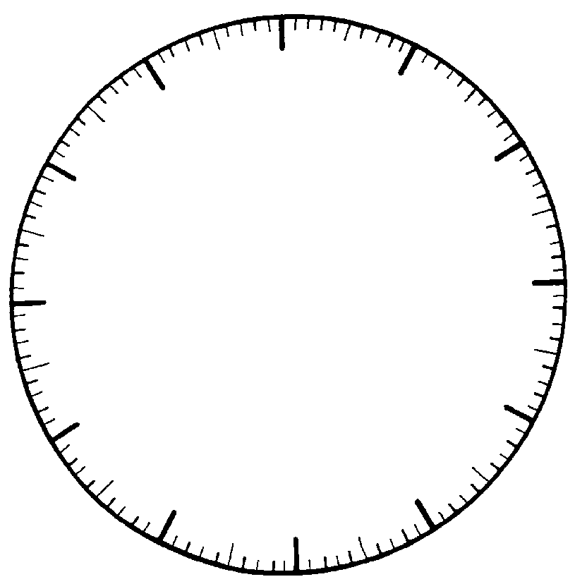
0
1100
1KG
900
800
200
100
300
400
700
600
500
grams
What is the weight shown?

What is the weight shown?
0
1100
1KG
900
800
200
100
300
400
700
600
500
grams

What is the weight shown?

0
1100
1KG
900
800
200
100
300
400
700
600
500
grams

What is the weight shown?

0
1100
1KG
900
800
200
100
300
400
700
600
500
grams
0
1100
1KG
900
800
200
100
300
400
700
600
500
grams
0
1100
1KG
900
800
200
100
300
400
700
600
500
grams

What is the weight shown?

What is the weight shown?

What is the weight shown?

0
1100
1KG
900
800
200
100
300
400
700
600
500
grams
0
1100
1KG
900
800
200
100
300
400
700
600
500
grams
0
1100
1KG
900
800
200
100
300
400
700
600
500
grams

What is the weight shown?

What is the weight shown?

Show 560 grams
0
1100
1KG
900
800
200
100
300
400
700
600
500
grams

Show 90 g
0
1100
1KG
900
800
200
100
300
400
700
600
500
grams

Show 420 g
0
1100
1KG
900
800
200
100
300
400
700
600
500
grams

0
1100
1KG
900
800
200
100
300
400
700
600
500
grams
0
1100
1KG
900
800
200
100
300
400
700
600
500
grams
0
1100
1KG
900
800
200
100
300
400
700
600
500
grams

Show 1kg 60 g

Show 670 g

Show 530 g

0
1100
1KG
900
800
200
100
300
400
700
600
500
grams
0
1100
1KG
900
800
200
100
300
400
700
600
500
grams
0
1100
1KG
900
800
200
100
300
400
700
600
500
grams

Show 240 g

Show 480 g

Show 710 g

1.
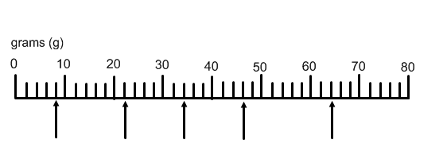
A B C D E

2.
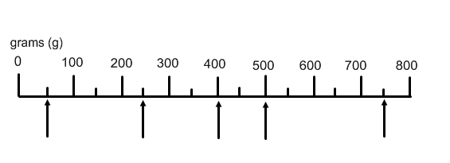
A B C D E
3. 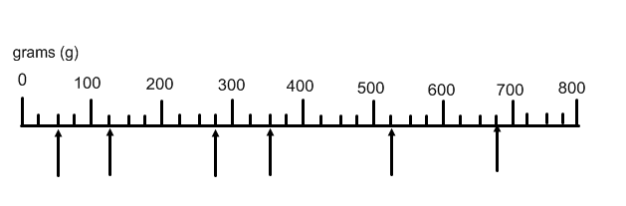
A B C D E F

4.
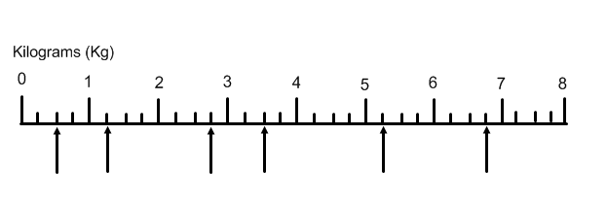
A B C D E F

