Fractions of Money a

Answer these questions:

- What is half of £10?

- What is a quarter of £10?

- What is half of £6?

- What is a quarter of £6?

- What is a third of £6?

Complete these statements:

6. £5 is half of ____

7. £6 is half of ____

8. £1.50 is a quarter of ____

9. £2.50 is a quarter of ____

10. £2 is a third of ____

Rosie Iribas 2005 E3 Fractions

Fractions of Money b

Answer these questions:

1. What is s third of £18?

2. What is two thirds of £33?

3. What is three quarters of £42?

4 What is a quarter of £42?

5. What is a third of £42?

Complete these statements:

6. ____ is a third of ____

7. ____ is two thirds of ____

8. ____ is three quarters of ____

9. ____ is a quarter of ____

10. ____ is a third of ____

Rosie Iribas 2005 E3 Fractions

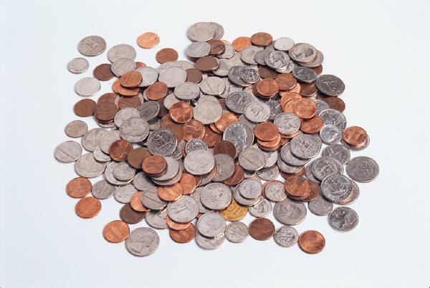
Coins and Fractions

Answer the following questions

- What is a half of a £1?

- What is a tenth of £1

- What is a fifth of £1?

- What is two fifths of £1?

- What is two fifths of £10?

- What is a sixth of £3?

- What is two sixth of £12?

- What is an eighth of £16?

- What are two eights of £8?

- What is two thirds of £6

Rosie Iribas Jan 06 E3/L1
Laminate and cut – Matching Game
Half of £1 | 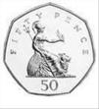
Quarter of £1 | 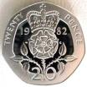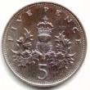
Two quarters of £10 | 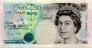
A third of £9 | 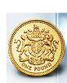
A fifth of £50 | 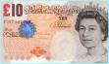
One tenth of £10
Two tenths of £1 | 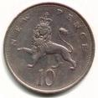
Sixth of £12 | 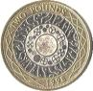
Two Sixth
of £12
Three quarters of £2
Two fifths
of £8

