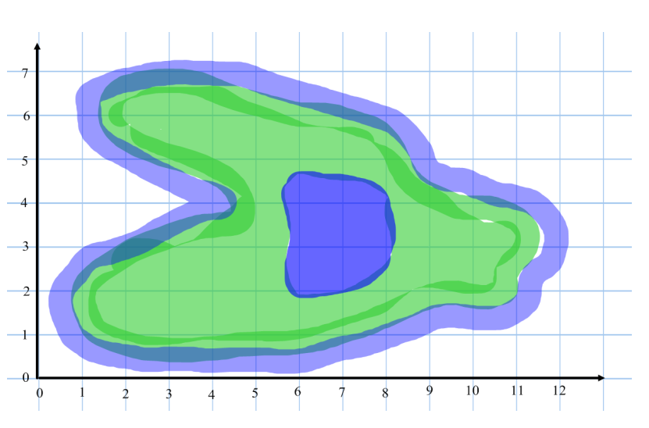
Name: _________________ Roman Archaeological Dig
Triangles
The island has many Roman remains hidden on it. Put a ‘C’ for each Roman coin found at the following coordinates: (4,2) (10,3) (3,6) (7,5) (6,6)
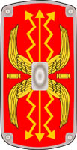
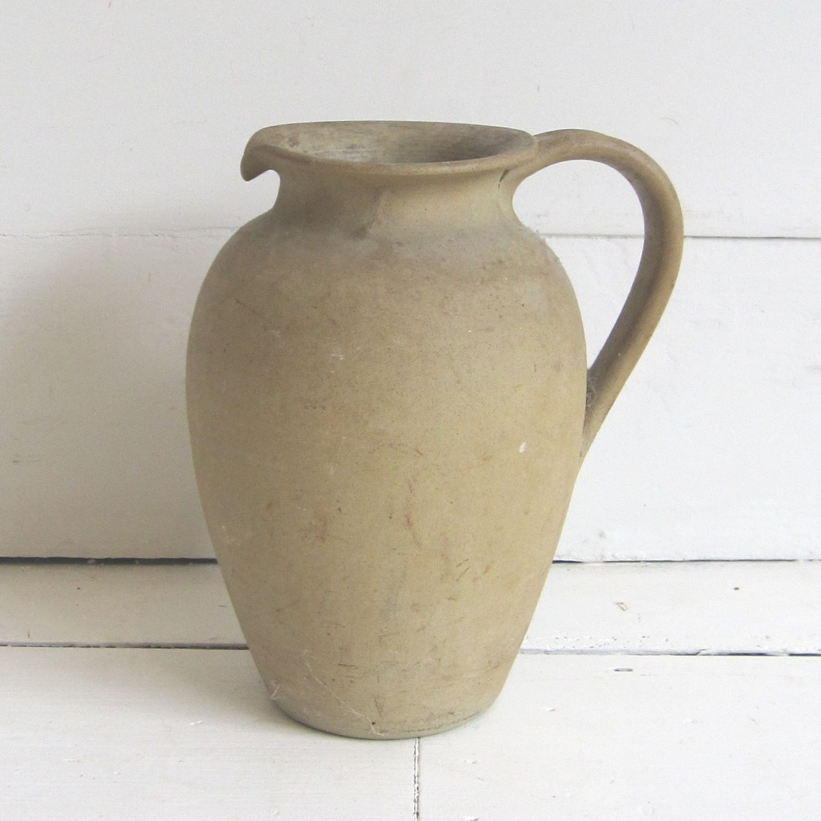
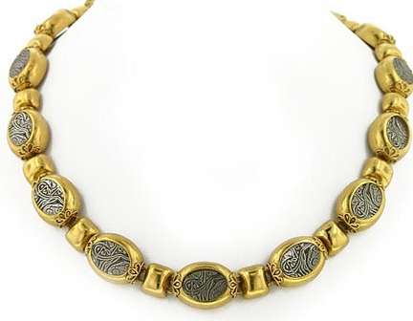
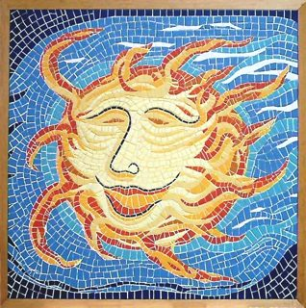
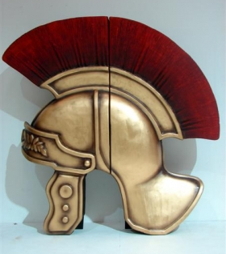
Write the coordinate of the following objects:
( , )
( , )
( , )
( , )
( , )

