TBAT round up after division

- I want to take 20 children on a trip. I can put 6 children in each mini bus. How many mini buses will I need?

Draw 6 children next to each bus until all 20 have a place.

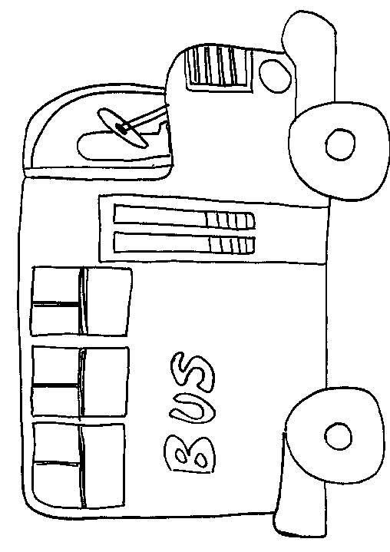

The total number of minibuses need is ___________________________

- I have 33 pencils. I want to put them into pencil cases. Each case will only hold 8 pencils. How many cases will I need?

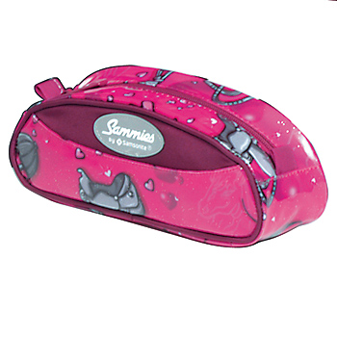
Draw 8 pencils next to each case until you have used all 33.

How many cases did you need? ___________________________________
- I have 29 sweets and I want to put them into bags. If I can fit 7 sweets in each bag how many bags will I need?

Draw 7 sweets in each bag until all 29 have been used.
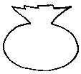
I will need ___________ bags for my sweets

- I have 17 toy cars I give 4 to each of my friends. How many friends can have a car?

Draw under each boy 4 cars until all 17 have been shared out.

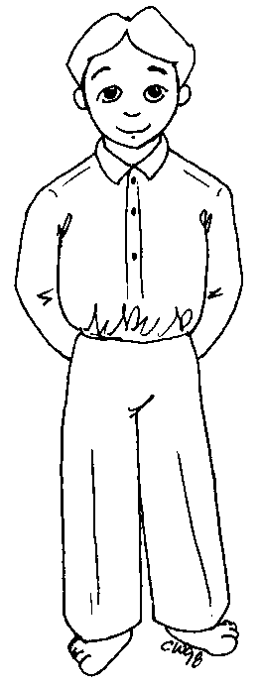

_______________boys got cars.
TBAT round up after division

- I want to take 20 children on a trip. I can put 6 children in each mini bus. How many mini buses will I need?

Divide 20 by 6. Look at your remainders carefully and remember to round up!

The total number of minibuses need is ___________________________

- I have 33 pencils. I want to put them into pencil cases. Each case will only hold 8 pencils. How many cases will I need?

Divide 33 by 8. Look at your remainders carefully and remember to round up!

How many cases did you need? ___________________________________
- I have 29 sweets and I want to put them into bags. If I can fit 7 sweets in each bag how many bags will I need?

Divide 29 by 7. Look at your remainders carefully and remember to round up!

I will need ___________ bags for my sweets

- I have 17 toy cars I give 4 to each of my friends. How many friends can have a car?

Divide 17 by 4. Look at your remainders carefully and remember to round up!

_______________boys got cars.
Extension

Try these in you book.

- I have 14 chocolates to put into boxes. Each box will hold 3 chocolates. How many boxes will I need?

- I now have 26 chocolates. How many boxes will I need?

- There are 23 chairs to put round tables. Each table needs 2 chairs. How many tables are there?

