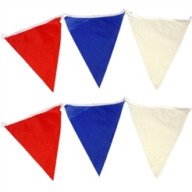
The Royal Wedding
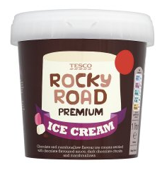  £1.43 | 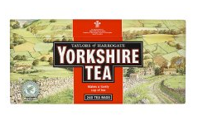  £0.89 | 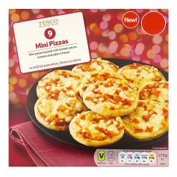  £2.09
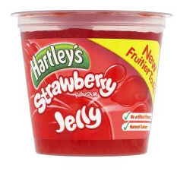  £1.78 | 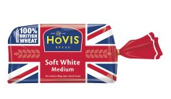  £0.25 | 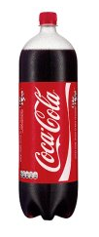  £1.31
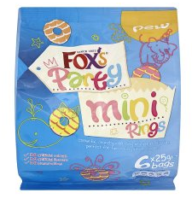  £0.55 | 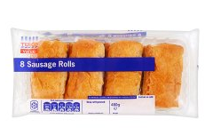  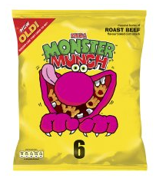  £2.63 | 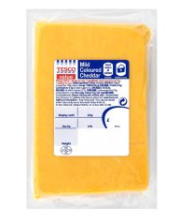  £0.66
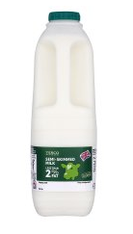  £1.18 | 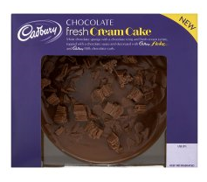  £2.11 | £1.37
Friday 28th April 2011
The Royal Wedding
Friday 28th April 2011

Shopping List 1  - bread  - tea  - cheese | Shopping List 2  - cake  - sausage rolls  - cola | Shopping List 3  - biscuits  - pizza  - crisps
Shopping List 4  - cola  - biscuits  - sausage rolls | Shopping List 5  - jelly  - milk  - cake | Shopping List 6  - ice-cream  - jelly  - cola

The Royal Wedding
£1.43 | £0.16 | £1.12
£0.72 | £0.85 | £1.21
£2.64 | £0.55 | £0.47
£1.38 | £2.74 | £1.91
Friday 28th April 2011
The Royal Wedding
Friday 28th April 2011

Shopping List 1  - sausage rolls  - tea | Shopping List 2  - cake  - cola | Shopping List 3  - biscuits  - pizza  - crisps
Shopping List 4  - cola  - biscuits  - sausage rolls | Shopping List 5  - jelly  - milk  - cake | Shopping List 6  - ice-cream  - jelly  - cola

The Royal Wedding
13p | 63p | 25p
22p | 6p | 54p
48p | 29p | 21p
37p | 35p | 14p
Friday 28th April 2011

Round the prices to the nearest 10p and estimate the cost of each shopping list. Then work out the actual cost of the foods listed.
The Royal Wedding
Friday 28th April 2011

Shopping List 1  - sausage rolls  - tea | Shopping List 2  - cake  - cola | Shopping List 3  - pizza  - crisps
Shopping List 4  - cola  - biscuits | Shopping List 5  - jelly  - cake | Shopping List 6  - ice-cream  - jelly  - cola

The Royal Wedding
£6.43 | £1.29 | £2.43
£3.82 | £3.16 | £1.92
£2.72 | £2.18 | £3.23
£2.48 | £0.89 | £2.75
Friday 28th April 2011
The Royal Wedding
Friday 28th April 2011

Shopping List 1  - milk  - bread  - tea  - cheese | Shopping List 2  - cake  - sausage rolls  - cola  - bread | Shopping List 3  - tea  - biscuits  - pizza  - crisps
Shopping List 4  - cola  - biscuits  - sausage rolls  - crisps | Shopping List 5  - jelly  - milk  - cake  - pizza | Shopping List 6  - ice-cream  - jelly  - cola  - pizza

The Royal Wedding
List | Estimate (using rounding) | Actual cost
1
2
3
4 |  | 
5
Friday 28th April 2011

